BODY WEIGHT EXERCISES

Plank – Pecs, anterior delts, traps, rhomboids, spinal extensors
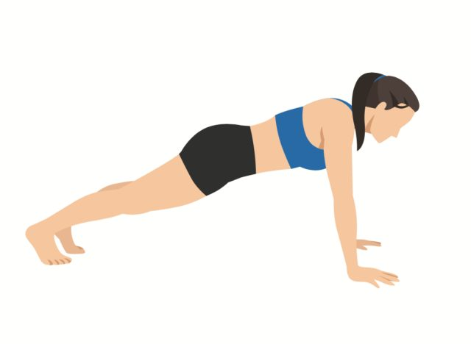Shutterstock
- Starting in an All-Fours position with hands under the shoulders and knees under the hips.
- Extend your legs and either balance on your toes or tuck your toes under and allow the ball of your foot to find the floor.
- Arms are either straight or, for added challenge, you can bend your elbows and press your forearms into the ground.
- Your posture is important here, your head, your ribcage, your pelvis through the legs to the heels should create a long, straight line. Maintaining this line is important to how the forces transfer from the upper body, through the core, to the legs.
- Holding this position, for anywhere from 30 seconds up to 2 minutes, is an excellent way to create overload and whole-body challenge.
- This is an isometric exercise, a static hold exercise. Studies show that isometric exercises build strength and endurance relatively quickly.

Push-Up – A dynamic version of a straight arm plank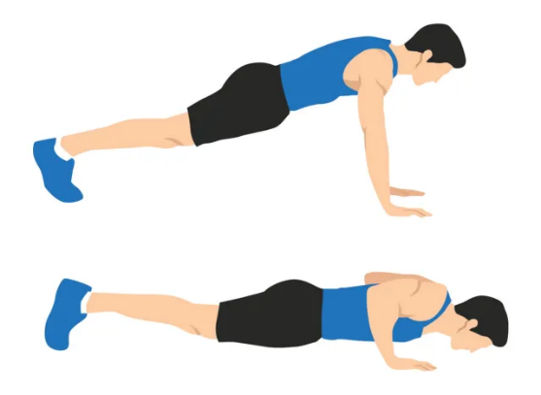Shutterstock
- From the straight arm plank position, bend the elbows and lower the body toward the ground.
- Maintain your long, straight body line as you lower.
- Straighten the arms to return to the starting position.

Dynamic exercises change the body’s relationship to gravity while also moving multiple joints, such as the shoulders, elbows, and shoulder blades. This increases muscle strength around moving joints, changes the way forces are put into and need to be responded to, and teaches the nervous system how to coordinate movement relative to gravity.

Side-Plank – Works obliques and side body muscles
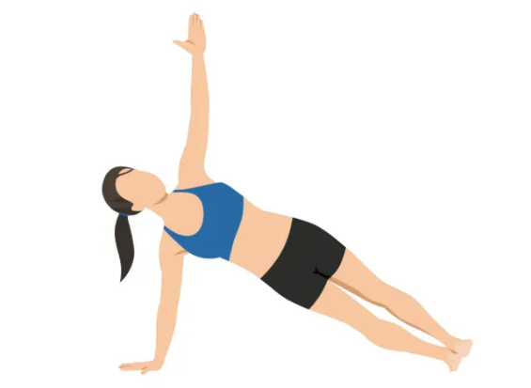Shutterstock
- Sit side facing and place your hand on the floor, or for more challenge, your forearm on the floor. Your hand or your elbow should be just under your shoulder.
- Lengthen out your legs and either stagger your feet, one in front of the other, or stack them one on top of the other for an added balance challenge and lift your hips until the body is in one long line.
- For the isometric version, hold for anywhere from 30 to 60 seconds.
- For the dynamic version: Lower your hips toward the floor, with control, then press into the sides of the feet and the forearm/hand and lift the hips to return to the side plank position.

With these plank exercises, the most common mistakes are breaking the body line at the hips by lifting the hips toward the ceiling or by squeezing the glutes and tucking the hips under and arching the lower spine.

Squats – Glutes, hamstrings, knee flexor muscles, quads
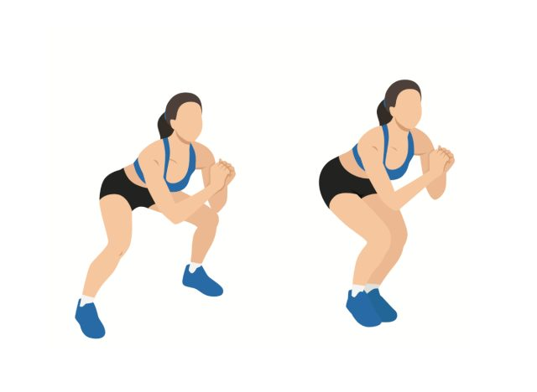Shutterstock
- Stand tall, with your head, ribcage, and pelvis all in line with one another and separate your feet roughly shoulder width apart.
- Bend your hips, knees, and ankles as you sit back, as if you were sitting in a chair.
- As you lower, your torso may tilt over your thighs, but it is important that you maintain the body line.
- Lower as far as you can while maintaining the body line.
- Stand back upright. Make sure to stand up as tall as you can before you descend again.
- For more challenge…hold when in the squat position for anywhere from 30 sec to 1 minute for an isometric challenge…or longer if desired. From the hold position, pulse within a small range of motion, creating more of a dynamic challenge.

Lunges – Glutes, hamstrings, knee flexor muscles, quads
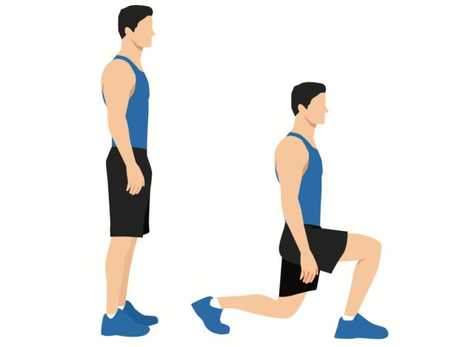Shutterstock
The lunge is directly related to walking and functional reciprocal leg motion.
- Stand up tall, creating one long body line, head, ribcage, and pelvis aligned and over the legs, which are straight.
- Step forward, bend both the front and the back knee, and lower toward the ground.
- Keep the body upright and the body line straight as the body lowers.
- Straighten your legs to return to the starting position.
- For more challenge…hold when in the lowered lunge position anywhere from 30 to 60 seconds. From the hold position, pulse within a small range of motion, creating more of a dynamic challenge.
- For more balance and functional challenges, start with legs together, step forward, lower, and step back to start.
With both squats and lunges, there are a few common mistakes:
- Sacrifice the body line for a deeper squat or lunge
- Lower spine arches or the pelvis/hips remain high as the torso lowers.

Heel Raises – Calves, ankles, and feet. Balance and coordination
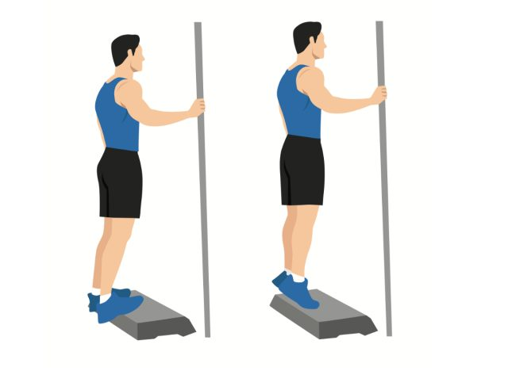Shutterstock
- Standing tall, with legs straight, press the floor away with your toes as you lift your heels.
- Lower with control and repeat.
- For an added challenge, stand on a step with the balls of your feet on the edge of the step. Lower the heels below the level of the step and then press the balls of your feet into the step as you lift the heels.

The biggest mistake here is being so focused on balance that you do not really move through a full range of ankle motion. Stand by a countertop or inside a door frame for just enough support that you have a full range of motion.
The second biggest mistake is to focus only on the heel raise phase…but the slow, controlled return is key to training balance and strengthening intrinsic muscles of the calf, ankle, and feet.

