Chase Bank Partnership for Vendor Payments
In an effort to streamline and modernize LSUHSC payables processes, Accounts Payable (including Travel and Direct Pay) will partner with Chase Bank (our contracted bank) for check printing and utilization of their Corporate Quick Pay Program (CQP) effective June 6th, 2022. This program will greatly reduce the University’s reliance on in-house check printers and also allow the opportunity for additional electronic payment options to certain types of payees.
Chase’s CQP Program Benefits:
- Reduce University cost of check supplies, equipment maintenance and employee check printing, sorting and mailing time
- Allows for more flexibility and accessibility for timely payments during hurricanes and other unforeseen emergencies
- CQP Program allows for ACH payments to non-employees paid through the direct pay and travel process reducing paper check and outstanding checks
- No fees to the payee; receive money quickly

Chase check printing- What does this mean for my department?
For PO related Accounts Payable payments, you will not notice any major changes to your departmental processes. For payments on Purchase Orders generated from the Accounts Payable area, instead of checks being printed in-house, a payment file will be sent to Chase Bank. The bank will then print and mail the checks to the address on file on the University’s behalf. Auxiliary vendor check payments will also be handled in this manner.
How will Direct Pay payments be affected by CQP (Corporate Quick Pay)?
The CQP program allows for a Business to Consumer ACH payment to be made to an individual’s personal email address and will greatly reduce the number of paper checks generated and streamline payments. The CQP payment platform allows for electronic payments to individuals not employed by the University.
What does my department need to provide on the Direct Pay Request?
Your departmental Direct Pay requests will continue to flow through the Payment Request functionality in PeopleSoft; the only difference will be the information requested for the payee.
LSUHSC employee:
- There are no changes to this process. If you are reimbursing an LSUHSC employee through Direct Pay, please provide their seven digit employee id in the notes section of step#1 of the payment request so a direct deposit can be initiated.

Non LSUHSC employee:
- If you are reimbursing or paying a non-LSUHSC employee, please include their personal email address in the notes section of step#1 of the payment request. The following is a list of common disbursement types sent to non-employees:
- Patient refunds
- Parking card buyback
- Clinical trial participants (use of Clincard preferred)
- Stipends
- Honorariums
- One-time contractor payments
- Royalties
- Other- non-employee reimbursement
If an email is not provided by the payee, a paper check will be delivered by Chase to the payee’s mailing address on file with LSUHSC.
Screen shot of Step#1 of the payment request functionality. Enter the requested information in the notes section.
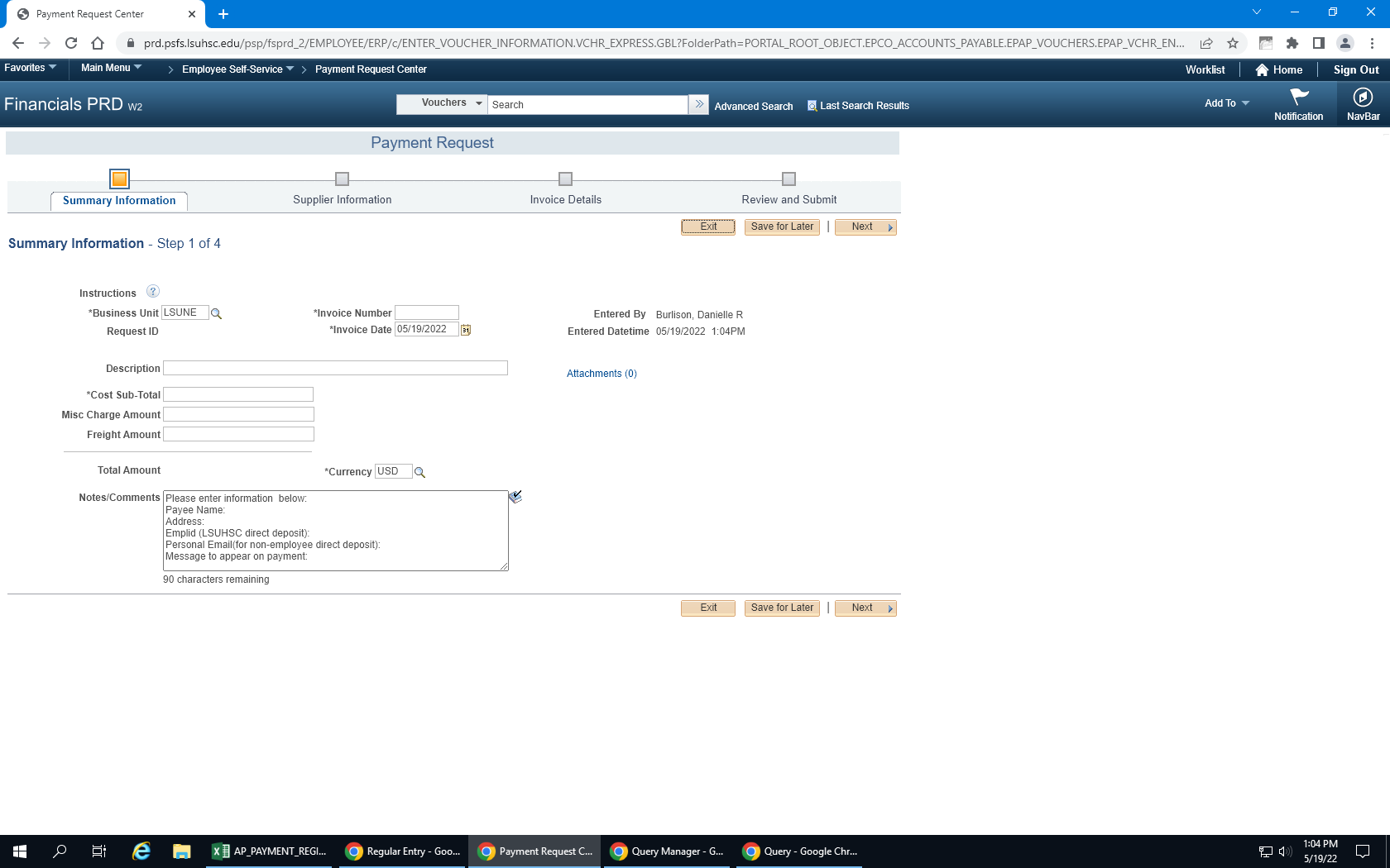

What happens once the Direct Pay payment is processed in PeopleSoft?
Once the direct pay request is approved in PeopleSoft, the pay cycle runs, and payment file is generated.
For non-LSUHSC employees, if an email address is provided by the department, the payee will receive an email notification that the payment is available. The payee will have 2 business days to retrieve the electronic payment. After this 2 day time period expires, Chase will redistribute the payment as a paper check and mail the payment to the recipient on LSUHSC’s behalf.
How are Travel reimbursements disbursed?
Travel reimbursements will be continue to be disbursed via direct deposit for LSUHSC employees; please be sure to include the employee’s LSUHSC employee id on their travel voucher.
For non-employee travel reimbursements, please include the payee’s personal email address. Their payments will be processed through the Chase CQP program (see above).

What are the electronic payments options to our Accounts Payable/PO related vendors and contractor?
Good news! In conjunction with Bank of America, LSUHSC has been utilizing electronic payments to our vendors for approximately 8 years and the list of vendors accepting these payment types is growing. Here are the electronic payment options we have for recurring vendor payments and incorporated contractor payments:
Epayables- credit card program is a way for LSUHSC to pay its invoices using a VISA credit card. With this program, the vendor receives an email as notification and authorization to charge the dedicated credit card after an invoice is approved in PeopleSoft. The remittance email provides the invoice number(s), invoice dollar amount(s), and credit card information to charge the transaction, and can be sent to multiple individuals in the vendor's organization.
Paymode X direct deposit program is an ACH program that allows LSUHSC to directly deposit invoice payments into the bank account the vendor specifies, along with complete remittance information that can be accessed at any time, after an invoice is approved in PeopleSoft. An email will be sent from Paymode X notifying the vendor of the deposit.
Website for vendor enrollment: http://www.paymode.com/lsuhsc
Form for sole-proprietors payees: PayModeX form for sole proprietor, contractor payments

Exceptions:
LSUHSC will retain in-house check printing capabilities for special handling, on-demand and emergency situations.

FAQ’s
- Are there any fees associated with Corporate Quick Pay?
  - No-there aren’t any fees to accept the electronic payment from Chase
- Does the recipient have to have a Chase bank account?
  - No, the recipient does not need have a Chase account. The Chase Corporate Quick Pay platform partners with Zelle, a person-to-person payment service available to almost anyone with a U.S. bank account- other banks that partner with Zelle — this includes Bank of America, Wells Fargo, US Bank and more.
- If paper checks were previously returned to my department, how will my department know when payments have been made?
  - Once the payment is generated in PeopleSoft, detailed spreadsheets and remittance advice information will be emailed to the department contacts. Some paper check payments will continue to be processed in-house.
- How long does it take to receive the electronic payment from Chase?
  - If the payee is already enrolled in Zelle through their bank, straight through processing is available and the payment will be available to the payee within minutes. If the payee is not registered to receive payments through Zelle, depending on the individual’s bank, registration may be required.

