

PeopleSoft Payables
Payment Requests (Direct Pay)

PR Requester Guide

June 2025

VERSION CONTROL
Version | Date | Task | Owner | Description
1.0 | 03/08/2019 | Create | Danielle Burlison | Document Creation
2.0 | 11/06/2020 | Create | Michele Gonzales | Detail document created.
3.0 | 05/01/2023 | Update | Barbara Doss | Combine the original documents created by Danielle and Michele.  Update for PeopleTools 8.59.05 – Fluid.
3.1 | 05/04/2023 | Review | Danielle Burlison | Review
3.2 | 05/05/2023 | Update | Barbara Doss | Update based on Danielle’s initial review.
6.0 | 05/31/2025 | Update | Barbara Doss | Update for PUM51 Upgrade
6.1 | 08/12/2025 | Update | Barbara Doss | Update for LSUNE
6.2 | 08/13/2025 | Update | Barbara Doss | Per Danielle Burlison: Remove Step 3- Details > Manual Entry section.

Table Of Contents
VERSION CONTROL 2
What’s New (PUM51) May 2025 5
Overview 6
Roles & Responsibilities 6
Chart-field Data Requirements 7
Document Retention 7
Scanning 8
Accessing PeopleSoft Payment Request Center 9
Payment Request Statuses 10
Payment Request Filters 11
Payment Request Links 12
Create a Payment Request 13
Step 1 – Summary 13
Step 2 – Supplier 17
Step 3 – Invoice Details 18
Option 1 – Accounting Tag Entry 18
Manage Favorites 18
Option 2 – Manually enter Accounting Details 20
Step 4 – Review and Submit 21
Update a Payment Request 24
Update a NEW Payment Request – Save For Later 24
Update a SUBMITTED or PENDING Payment Request 26
Cancel a Payment Request 27
Copy a Payment Request 28
Payment Request Messages 29
FAQ – Frequently Asked Questions 32
Scanning 32
Creating Payment Requests 32
Reviewing Payment Requests 32
Approving Payment Requests 32
Payment Request Vouchers 33
Payment Request Payment Confirmation 34

What’s New (PUM51) May 2025
- Added the Payment Address field in the Supplier Information page.
- Added an option to edit the supplier payment address while creating or updating payment request transactions.
- Added the Delegation Framework feature for Payment Requests.
- Validate duplicate invoice numbers before submission, review and approval of a request.
- Fluid Payment Request template to include new fields: Handling Code, Payment Message, and Separate Payment.
- Requesters can now update payment requests until the transaction has been fully approved.
- Requesters can now create a new request by copying from an existing request.

Overview
The PeopleSoft Payment Request process replaces the current process for Direct Pay (non-purchase order) requisitions. The process follows a step-by-step pathway to assist you in entering all required data and attachments to request a payment.

Roles & Responsibilities
Once a Requester submits a payment request, the Direct Pay PR Reviewer will review the document for accuracy before submitting the request to the appropriate approver(s) via workflow/email.

Payment Requests MUST be approved by the Department Approver(s) before payment processing can occur.

Payment Request roles include:

  - Requester – Creates the Payment Request (Formerly known as Requisitions)
  - Reviewer – Direct Pay user responsible for reviewing and identifying missing information before submitting for Department approval.
  - Department Approver – Ensure all of the information on the transaction is correct before approving and/or adding an Ad Hoc Approver if applicable. This includes account and amount restrictions.
  - Ad Hoc Approver – (Optional) Generally added by the Department Approver for additional approval at the department level for amounts of $10,000 or greater. Other reasons determined by the Department Approver may also apply.
  - Admin – Reviewer (Only when necessary to troubleshoot problems.)

Chart-field Data Requirements
For all accounts except accounts that start with 222XXX and those excluded above, the Fund code requirements are as follows:
- Fund 111 – Account, Fund, Department, Program and Class
- Fund 115 – Account, Fund, Department, Program and Class
- Fund 112 – Account, Fund, Department, Program, Class,
PC BU of LSUNO, Project ID and Activity ID of 1
Note: If there is no Project ID, there should be no Activity ID.
- Fund 113 – Account, Fund, Department, Program, Class,
PC BU of LSUNO, Project ID and Activity ID of 1
Note: If there is no Project ID, there should be no Activity ID.
- Fund 414 – Account, Fund, Department, Program, Class,
PC BU of LSUNO, Project ID and Activity ID of 1
Note: If there is no Project ID, there should be no Activity ID.

Accounts that start with “222XXX”
- Fund 111 – Account, Fund, and Department

Account 514000 and Department ID 1980003 (combo)
- Fund 111 – Account, Fund, and Department

Document Retention
The Department submitting the payment request is required to keep the original documentation in accordance with LSUHSC Records Retention policy.

Accessing PeopleSoft Payment Request Center
To begin creating a Payment Request, you will need to log on to PS PeopleSoft Financials Production (PS9FSPRD) database.

Click the PeopleSoft PS Launcher from your Citrix PS Desktop.

Enter your User ID and Password
Click Sign In

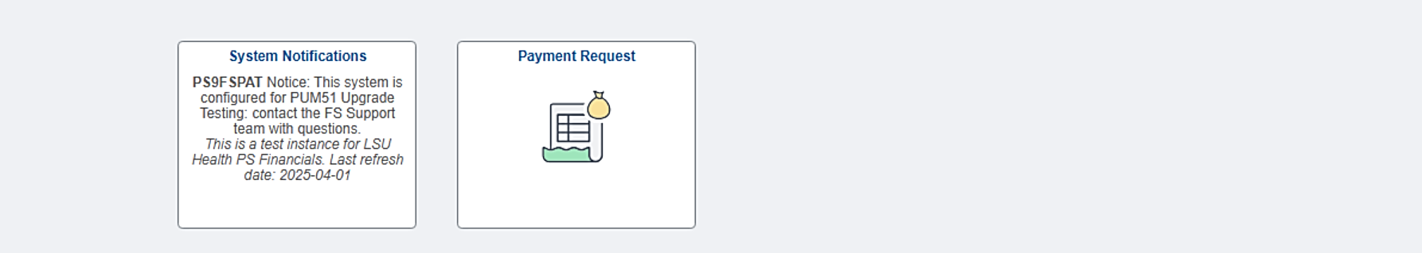
The system will take you to the “My Financials Home” homepage as the log-in landing page.

Payment Request Statuses
Below are the all of the available statuses in the Payment Request Center.
Payment Request Status Definitions
- Approval History – Will appear for Payment Requests with a status of Pending, Approved or Vouchered.
  - Denied Either the Department Approver or the Purchasing Approver has denied the Payment Request. You should receive an email notification for Denied Payment Request.
  - Submitted A Payment Request was entered and submitted and is awaiting review by the PR Reviewer.
  - Pending A Payment Request has been reviewed by the PR Reviewer and has been submitted for Department approval and Purchasing approval.
  - Approved A Payment Request has been approved.
  - Vouchered A voucher has been created for the Payment Request. The voucher will show a Scheduled to Pay of Paid or the actual date the payment is scheduled on.
  - New Payment Request was entered and the “saved for later” option was selected; not submitted.
  - Cancelled The Payment Request has been cancelled

The Payment Request Center will only show transactions for your User ID and only for the applicable status.

To view a specific status, select the Filter icon.

Note: You can view all Status at once or a single status individually.

Payment Request Filters
By Date
By Alternate Filters

Payment Request Links

- Update – The Payment Request can be updated as long as it is not approved.
- Message – A message exist for the Payment Request.
- Approval History – This is displayed after the PR Reviewer has reviewed the Payment Request and submitted it for approval. It will display the Department Approvers, Ad Hoc Approvers (if applicable) and Purchasing Approver(s).
  - The status is Pending.
  - This link is also available if a change is made to a reviewed Payment Request. (The status reverts to Submitted).
- Cancel – Use Caution This action will delete the Payment Request.
- Copy – You can copy the payment request to create a New Payment Request.

Create a Payment Request
NAVIGATION: My Financials Home > Payment Request tile

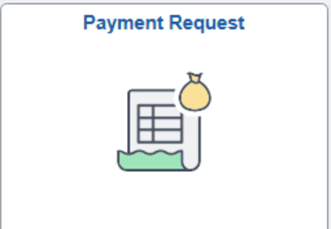

Click the “+” sign

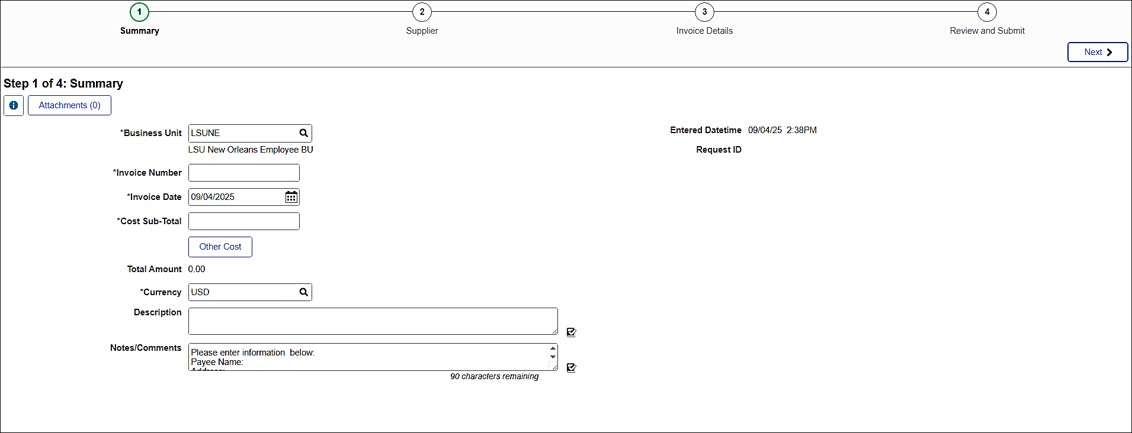

Step 1 – Summary
Enter the following Information
- Business Unit: LSUNE (This should default)
- Invoice Number: This is the Direct Pay number that will be recorded in PeopleSoft. The Invoice number should be formatted as follows:
- DP/DEPARTMENT NUMBER/4 DIGIT SEQUENTIAL OF YOUR CHOICE
- EXAMPLE: DP1651000A001
Note: Duplicate Invoice Numbers are not allowed for a supplier. If the number already exist for this supplier, you will receive the below message when attempting to save.

- Invoice Date: Enter the Payment Request date.
Note: The date will default to the current date so be sure to confirm the correct date for the invoice and change if needed.
- Cost Sub-Total: Enter the total amount to be paid.
- Other Cost
  - Misc. Charge Amount: DO NOT USE
  - Freight Amount: DO NOT USE
- Description: Enter the brief description/purpose of the request. The Description field allows 50 characters. If more than 50 characters exist and you attempt to move to the next field, you will receive the following message and instructions.

- Notes/Comments: Add the payee’s name and address, employee id (if you are reimbursing an employee) and any comments you’d like to appear on the check (i.e., invoice number, name reference etc.) that the Reviewer needs to know such as any comments that need to appear on the check or if this payment is to go to a specific supplier and/or address. There are only 254 characters so any notes will need to be concise. Note: You can also “Spell Check Description” by selecting the icon.

If this is a new supplier, a scanned/attached copy of the W-9 is required. (Attach this information in Step 1). You can enter the Supplier name and address information on the next screen. (Step 2 – Supplier Information).

If the address on the invoice is different from the one the payment is to be mailed to, a scanned/attached copy of the W-9 with the correct address is required.

- Attachments: (REQUIRED) Attach your invoice and supporting documents.
If scanning a W-9, be sure to scan the W-9 separately from the supporting documents. This will give you two attachments.

Note: You will not be allowed to move to the next page if there is no attachment.

Click attachments link
Click the “+” sign.
Click 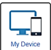
Select your file(s) and click Open
Click Upload
Click Done
Add a Description (Optional)

If you upload a file in error, click the Edit button, select the file and click Delete
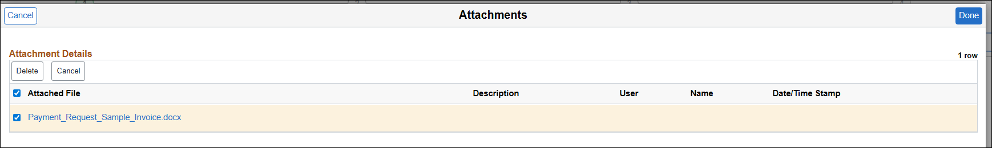

Note: You can attach up to 10 documents at one time. If you attempt to attach more than 10 documents at one time, you will receive the following message.

Click DONE

You can also click the  link for more information.

Click Next to move to Step 2 – Supplier
Step 2 – Supplier
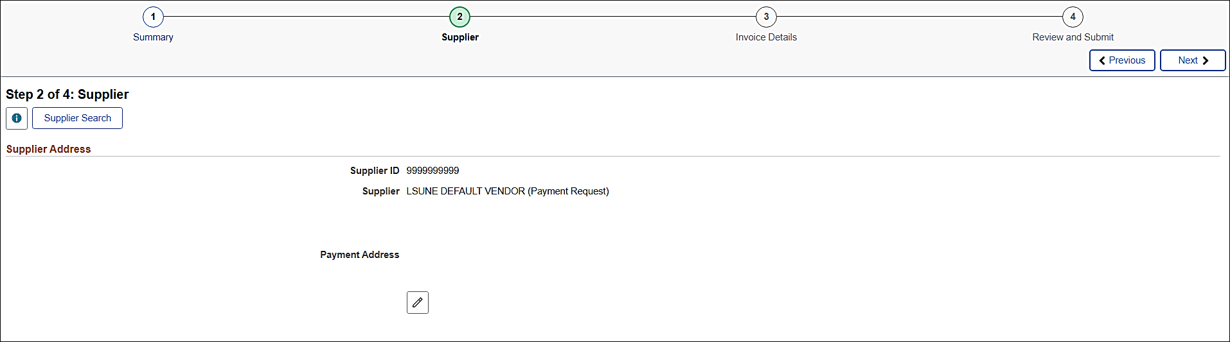
Use the Default Supplier (Leave as is) – The default Supplier ID 9999999999 is setup specifically for the Payment Request functionality. Upon review by the PR Reviewer, the correct named Supplier in the Notes/Comments field from Step #1 will be populated in this data field.

Click Next to move to Step 3 – Invoice Details
Step 3 – Invoice Details
This step two (2) options for adding chart-string information.
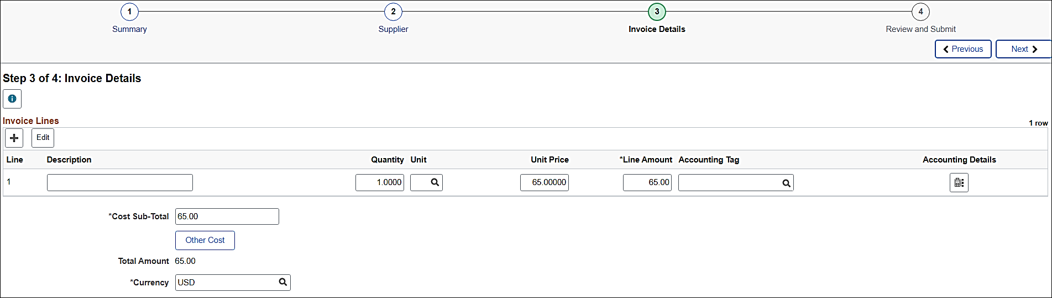
Enter the following for Line 1:
- Description: List any details (Optional).
- Quantity: (Optional).
- Unit: (Optional).
- Unit Price: (Optional).
- Line Amount: (Defaults from Step 1)

Option 1 – Accounting Tag Entry
Click the Accounting Tag magnifying glass.
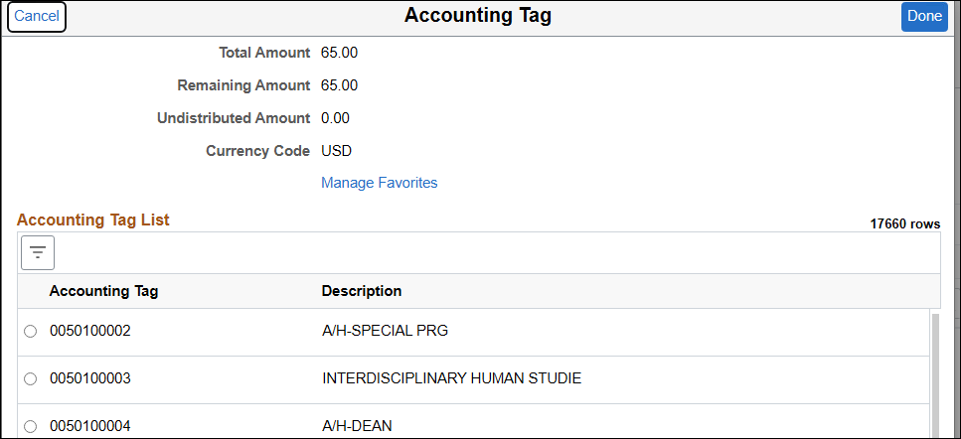

Manage Favorites
Select the Manage Favorites link.

On the "Manage Favorites" page, you have two options:
- Select from the entire list: Scroll through all available tags, check the boxes for the ones you use frequently, and click Save.
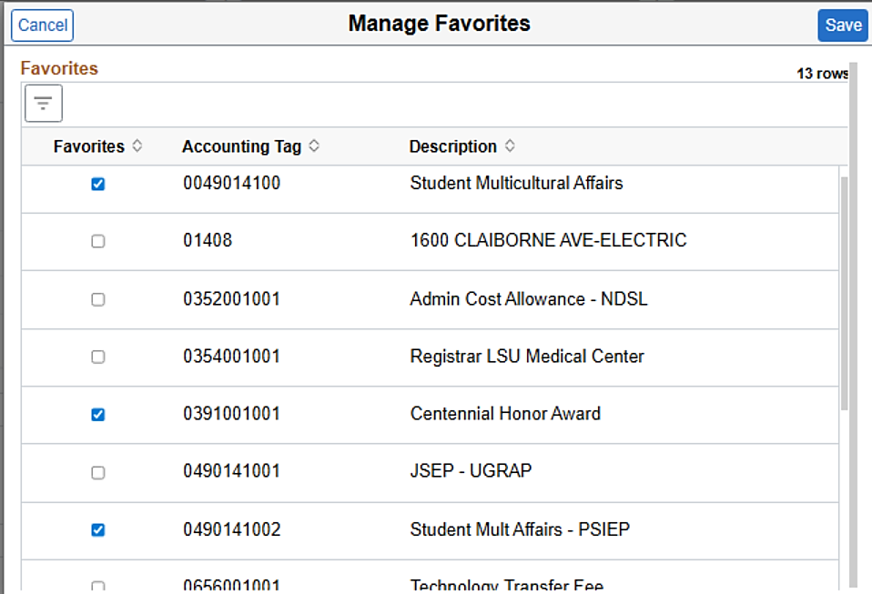

- Add a single new favorite: Use the search feature to find the desired accounting tag, check the box next to it, and click Save.

Click the Accounting Tag magnifying glass.

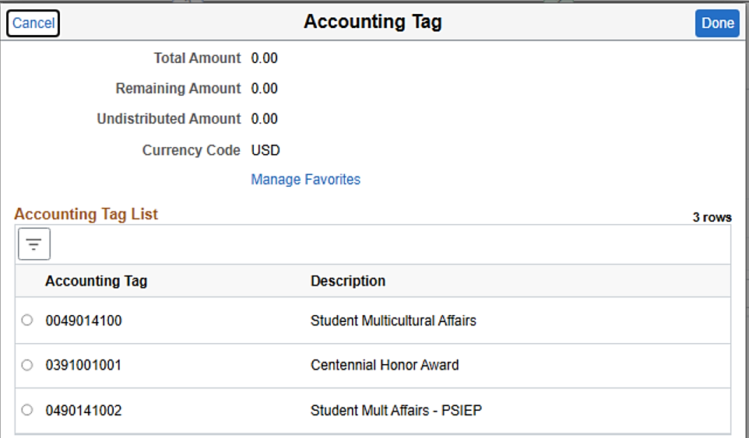
Select the Accounting Tag
Click Done

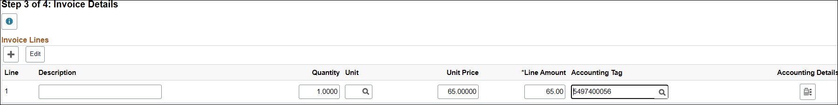
Click the Accounting Details Distribution  link.

Select the Show All tab or enter data one tab at a time.
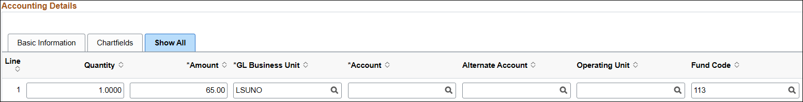
Confirm the applicable information; update as needed.

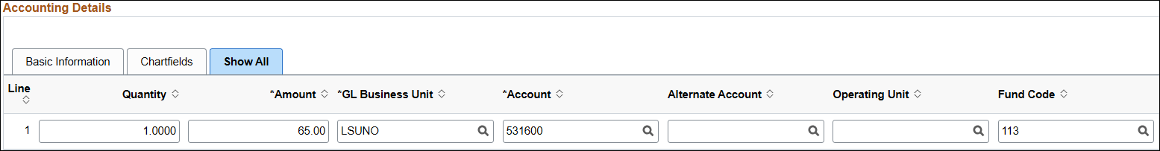
Click Done

Option 2 – Manually enter Accounting Details
Click the Accounting Details Distribution link.

Select the Show All tab or enter data one tab at a time.
Confirm the applicable information; update as needed.

Click Done

Click Next to move to Step4 – Review and Submit.

Step 4 – Review and Submit
Information for Steps 1 through Steps 3 is available on this page. Each section can be condensed or expanded as shown below.
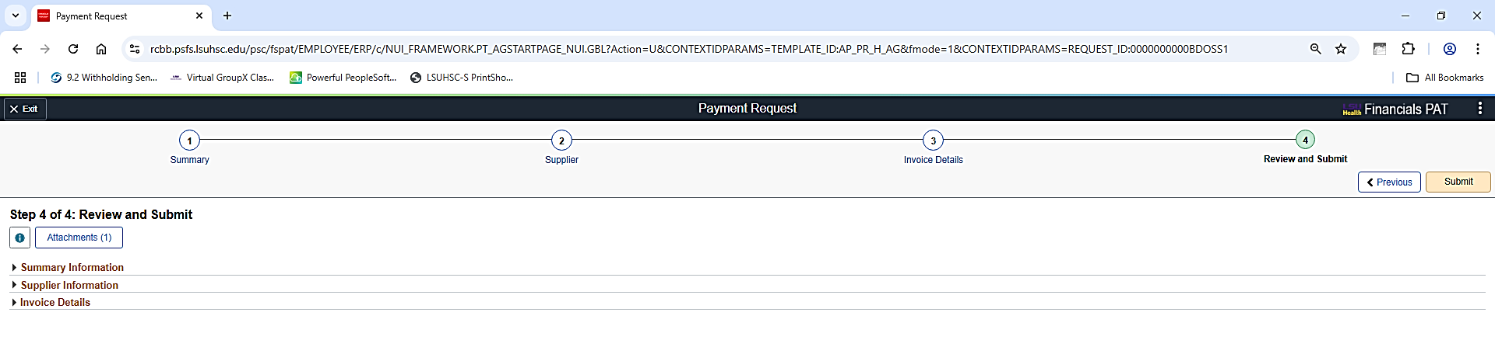
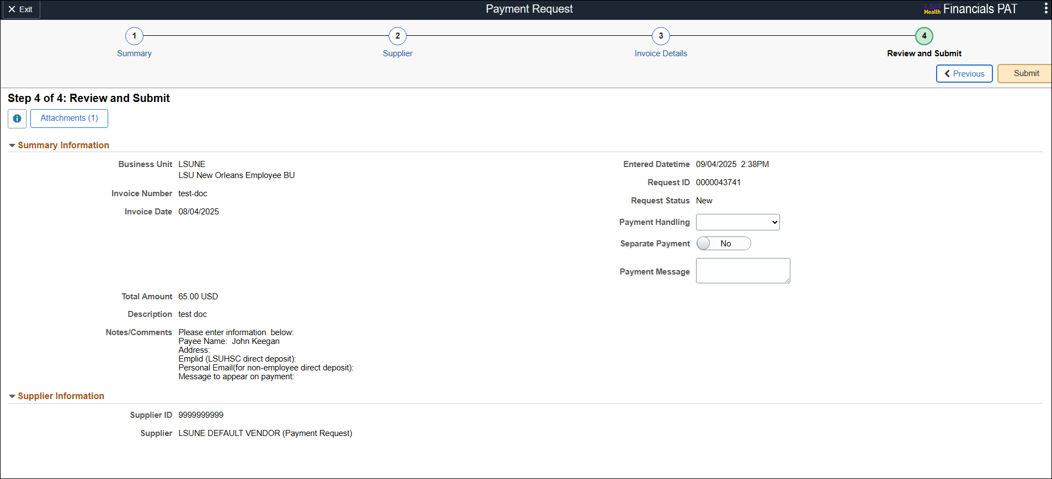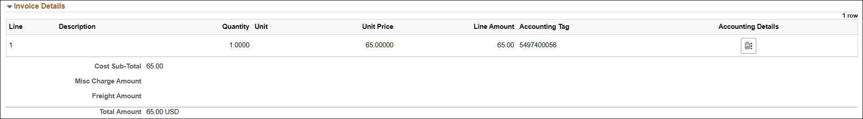

Prior to Submitting the Payment Request for review, you can set the below options if applicable.
Payment Handling: Select Regular Payments or Special Handling
Separate Payment: Yes or No
Payment Message: Enter a message that will appear on Voucher Payment tab when the voucher is build.
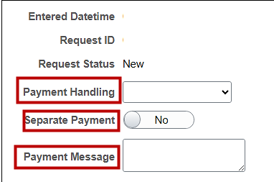

Review the following:
- Attachment(s)
- Invoice Number
- Invoice Date
- Supplier Name
- Supplier Address
- Notes/Comments
- Amount
- Funding Source/Chart-fields

If you need to make any corrections to the previous steps, you can select that step by clicking on any of the step icons shown below.

If the request is not complete, click the 3-dots in the upper right-hand corner of the page and select Save Fro Later.
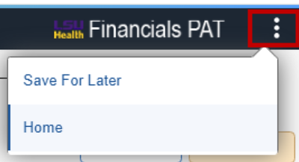
“Save For Later: Payment Requests will appear in the Payment Request Work Center with a status of “New”.

If the request is complete, click the Submit button.

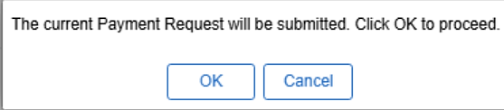
Click OK

The Payment Request will now show in your Payment Request Center with a status of “Submitted” (Awaiting review by the Direct Pay PR Reviewer).

AFTER the PR Reviewer has reviewed the Payment Request and submitted it for approval the status will show as Pending and the Approval History link is available.

Update a Payment Request
You can update a Submitted Payment Request up to the time of Approval. If the Payment Request is at a status of Pending and a change is made, the status will revert to Submitted. The Reviewer must review again and re-submit for approval.

Update a NEW Payment Request – Save For Later
If, while working on a Payment Request, you need to save your information to complete it later, click the 3-dots in the upper right-hand corner of the page and select Save For Later.
After clicking the Save For Later option, the following message will appear:

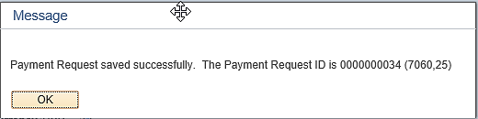
Click Ok

When you are ready to complete this request, click the Payment Request tile found on your homepage.
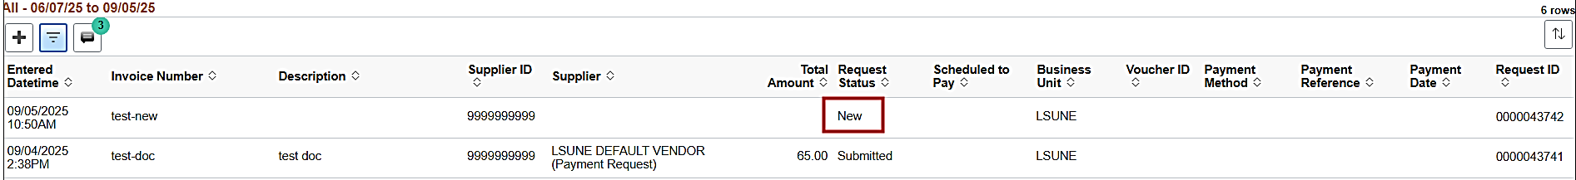
Select the desired Payment Request with the status of New.

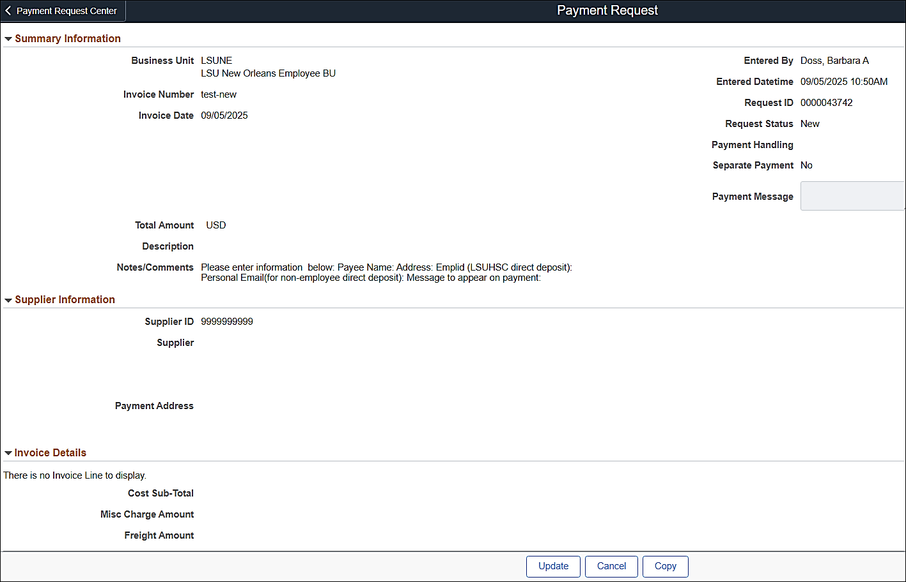
Select Update

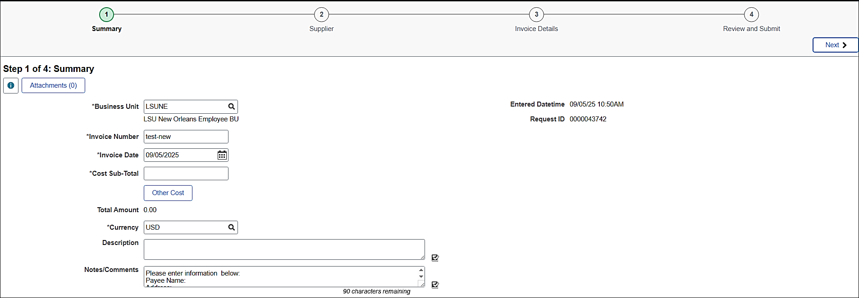
Make the necessary updates, click Next until you get to the Review and Submi page and click
Submit to process your Payment Request.

The Payment Request now has a status of Submitted.

Update a SUBMITTED or PENDING Payment Request
You can update a Submitted Payment Request up to the time of Approval. If the Payment Request is at a status of Pending and a change is made, the status will revert to Submitted. The PR Reviewer must review again and re-submit for approval.

Click the Payment Request tile found on your homepage.

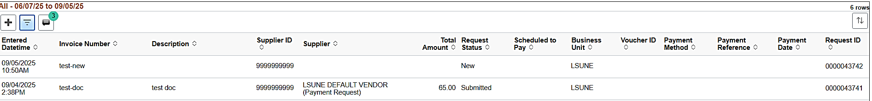
Select the Payment Request with the status of Submitted or Pending.
Select Update
Make the necessary updates, click Next until you get to the Review and Submit page and click
Submit to process your Payment Request.

The Payment Request has a status of Submitted.

Cancel a Payment Request
To cancel a Payment Request, select the applicable line from your Payment Request Center.

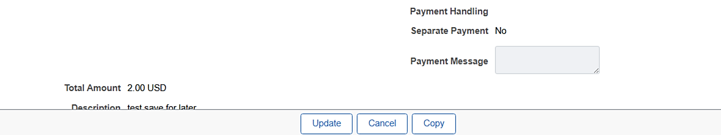
Click the Cancel

Verify that you want to Cancel (delete) the Payment Request.

Click Ok

The Payment Request has been cancelled and will show with a status of Cancelled in the Payment Request Center.
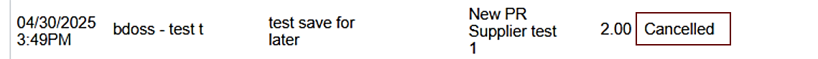

Copy a Payment Request
Copying a Payment Request will copy all information except the following:
  - Attachments
  - Supplier Information

Navigate to your Payment Request Center

Select the Payment Request to be copied.

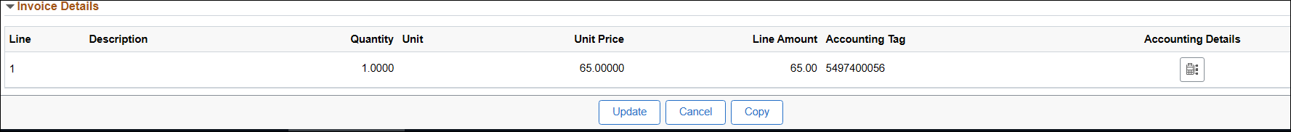
Click Copy

A new Payment Request page will open.
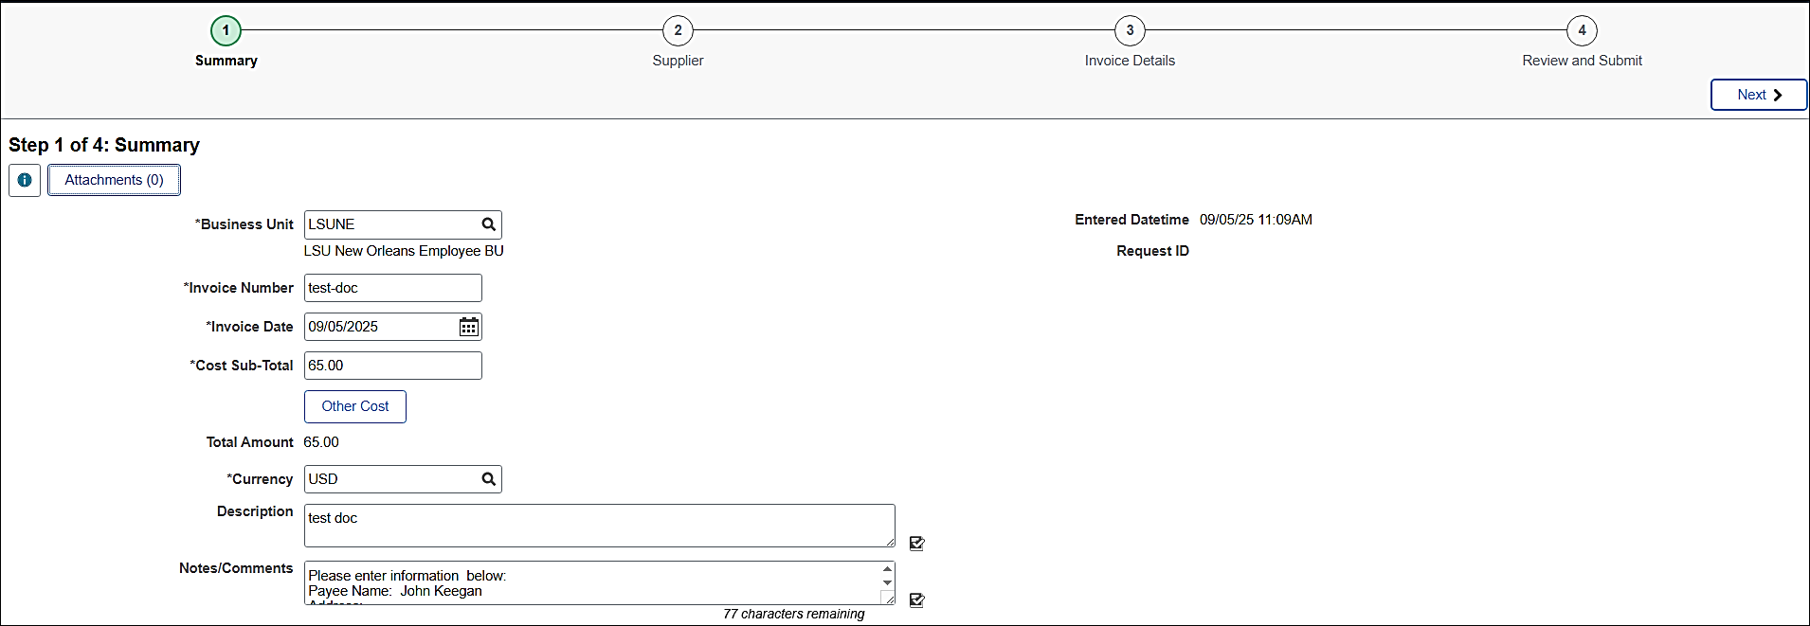
All information is copied except the Attachments and Supplier ID

Step 1 Attach the applicable document.
Update the Invoice Number. Note: Duplicate Invoice numbers are not allowed for a supplier.

Click Next until the Payment Request is completed and ready for submission.

The new Payment Request is created.

Payment Request Messages
At times you may receive a message from the Reviewer via email.

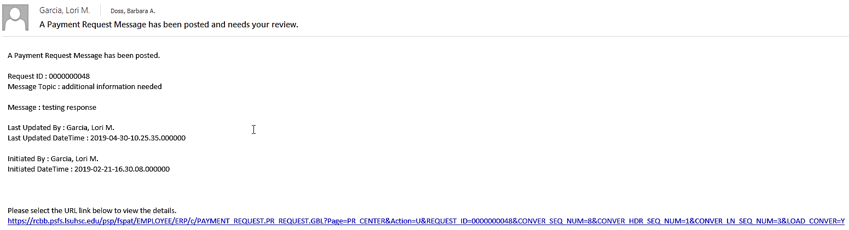
You can click the email link to see the details.

Both you and the Reviewer will see the green circle with the number of messages to be reviewed.
Click the Recent Messages  icon to view the messages.

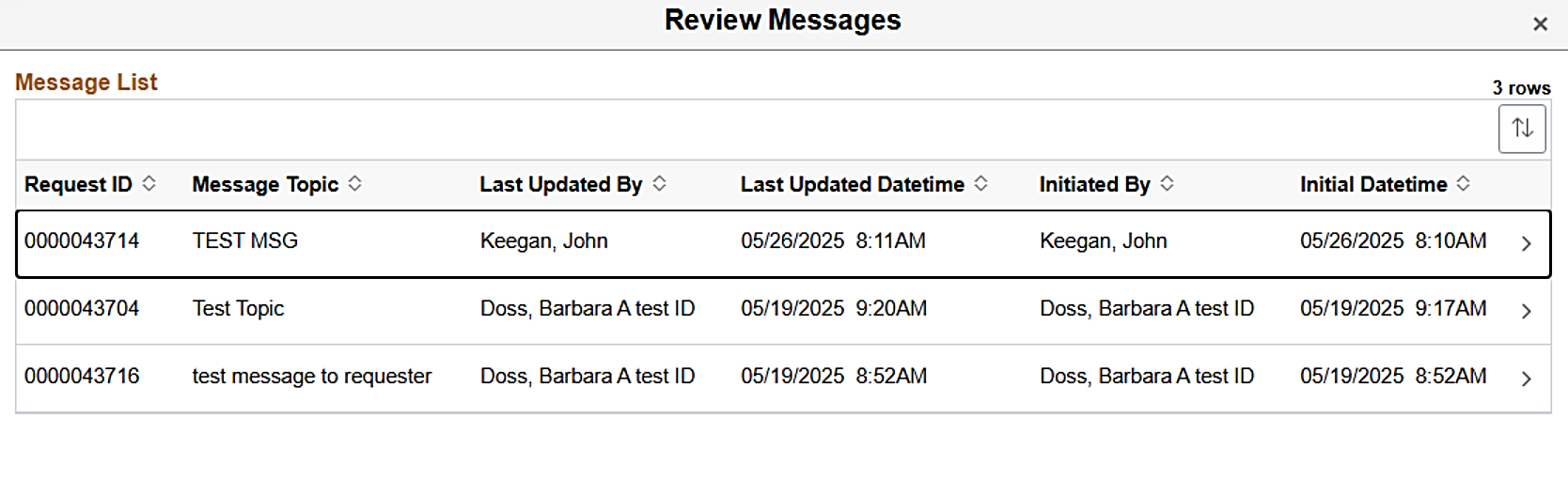
Click the message line to review.
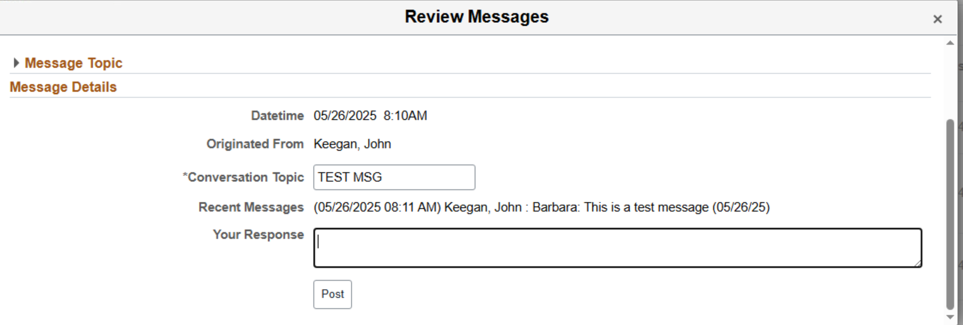
Review the message and complete any necessary tasks on the applicable Payment Request.

To respond to the Reviewer, enter your response the the Your Response box.
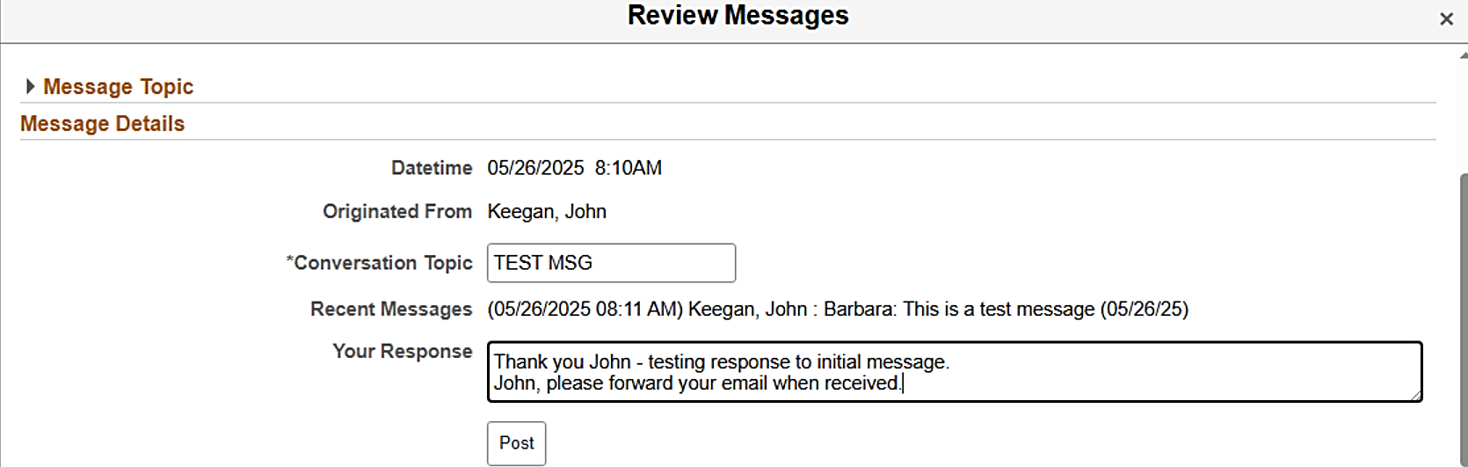
Click Post

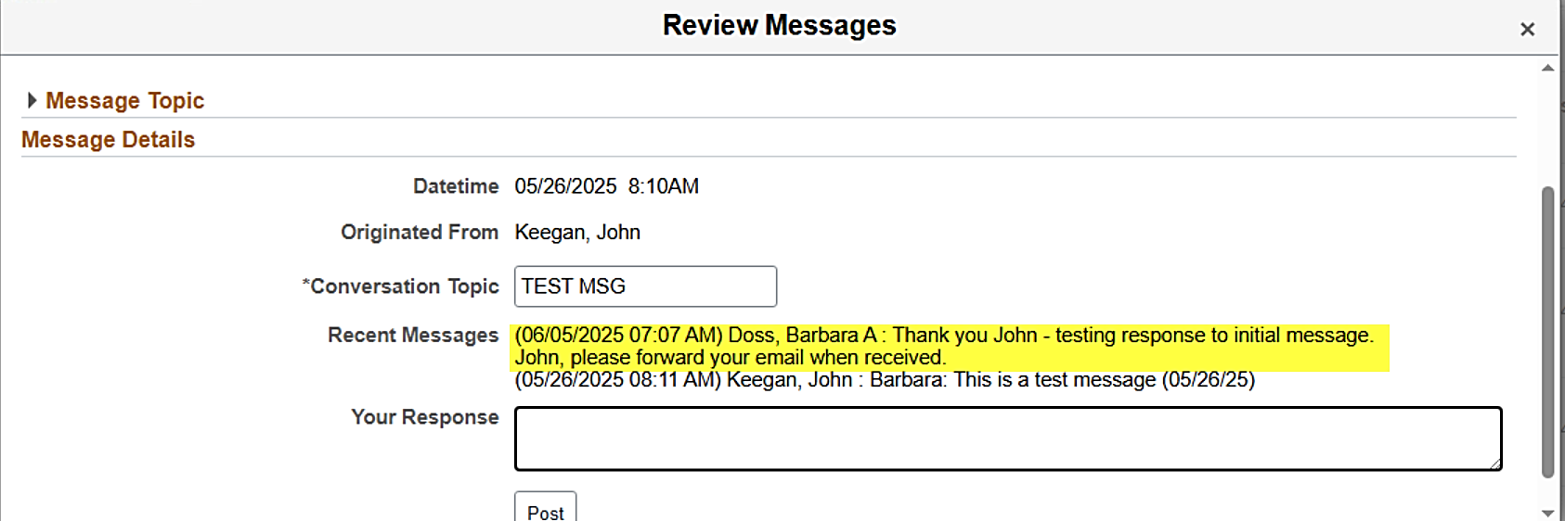
Click the ‘X” when completed.

The Reviewer will receive an email similar to the one shown below.
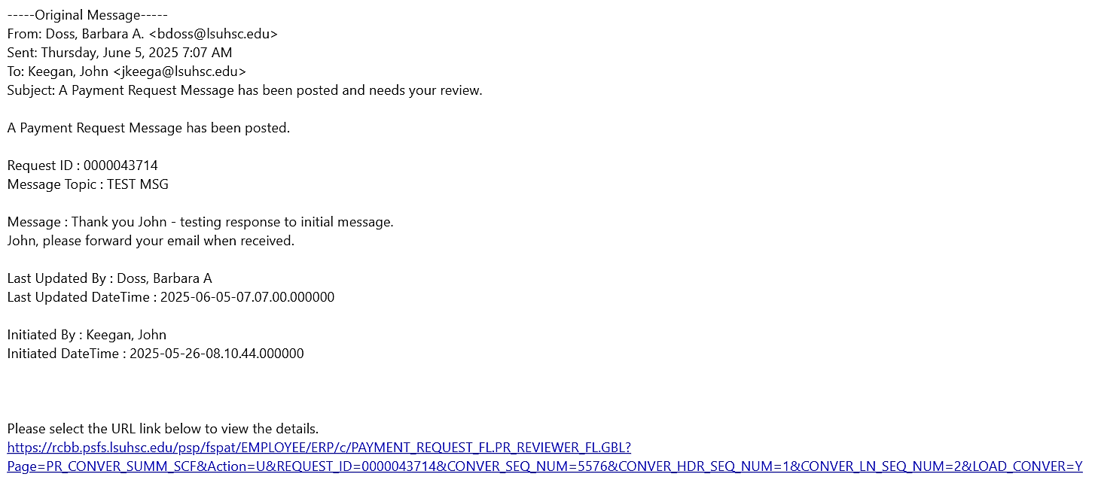

You can also view the message from the Payment Request line.

Select the applicable Payment Request.

Select Message at the bottom of the page.

FAQ – Frequently Asked Questions

Reviewing Payment Requests
- If DP needs more documentation in order to pay a Payment Request, how is the department notified?
DP will create a Payment Message within the Payment Request record which will trigger an email to the PR Requester.

Approving Payment Requests
- Why is workflow setup like that? Shouldn’t DP be at the end?
Workflow is set up to flow from PR Requester > Direct Pay PR Reviewer > Department Approver.
Since Payment Requests produce a fiduciary responsibility, the DP staff are not allowed to act on behalf of another person to approve payments of any kind. That responsibility falls to the Department Approvers.

- Can the PR Requester approve his/her own Payment Request?
No.

- Can the PR Requester also be an approver?
Yes, but not for Payment Requests they create.

- If a Coordinator creates the Payment Request, is there a way for the Business Manager to electronically sign it showing they approve the Payment Request?
Yes, via Payment Request workflow; if the Business Manager has been assigned Approval authorization for that department.

- Will the Payment Request be sent to Purchasing for their approval before it goes to Direct Pay?
No. The Payment Request must first go to the Direct Pay PR Reviewer for review, then to the Department Approver for final approval.

- What happens if a Payment Request is denied?
Payment Requests can only be denied by the Department. If an Approver denies the request, an email will be sent to the PR Requester and the PR Administrators for follow-up.

- When a PR Requester clicks on the look-up icon for approvers, who will show in the drop-down approver list?
All authorized approvers for the Department ID will appear in the drop-down list for Approvers.
If the individual submitting a Payment Request (PR Requester) also has authorization to approve Payment Requests, they will only see Payment Request’s drop-down list as an Approver. This upholds institutional policy for “separation of duties”, where Payment Request Requesters are not permitted to approve Payment Requests they create.

- What if the approvers are incorrect?
To add/delete or change approvers for a department, the Department Business Manager must send, via email, authorization to dburli@lsuhsc.edu .

Payment Request Vouchers
- Once the PR Reviewer reviews a Payment Request, will a voucher number be created and sit there until the next check run?
No. Once the Payment Request is reviewed, workflow is triggered and the Payment Request is sent to the Department Approver. Once the Department Approver approves the Payment Request, it becomes available for the Voucher Build process, which is scheduled to run daily, to create the actual voucher. At this point the voucher is available for the payment processing steps.

- A Payment Request shows vouchered in the PR Center; however, it is not viewable in the AP lookup screens and has not been paid.
When the Voucher Build process was run there was an error with either Supplier ID, location, etc. The error was never corrected via Voucher Build Error Detail page. The PR Reviewer must correct the problem. The voucher will then show correctly in the Payment Request Center.

Payment Request Payment Confirmation
- What will be sent back to the department as supporting documentation?
A copy of the Payment Request Review page summarizing the Payment Request information will be attached to the check.

END OF PROCESS

