

PeopleSoft Payables
Payment Requests (Direct Pay)

Approver Guide

June 2025

VERSION CONTROL
Version | Date | Task | Owner | Description
1.0 | 08/13/2025 | Create | Barbara Doss | Document Creation
2.0 | 09/04/2025 | Update | Barbara Doss | PUM 51 Upgrade

Table of Contents
VERSION CONTROL 2
What’s New (PUM51 Upgrade) May 2025 5
Overview 6
Roles & Responsibilities 6
Policy – Types of Purchases Not Allowed 7
Chartfield Data Requirements 7
Document Retention 7
Managing Payment Request Approvals 8
Adding the Approval tile to your Homepage 8
Approving Payment Requests 10
Approving a Payment Request via Email 10
Approving a Payment Request via the Approvals tile 13
Placing a Payment Request on Hold 16
Denying a Payment Request 18
Adding Ad Hoc Approvers 19
Department Approvers adding Ad Hoc Approvers 19
Purchasing Approvers adding Ad Hoc Approvers 22
Self Approvals 23
Missing Department Approvers – (ADMIN Approvers only) 24
Pushback 25
Approval Timeouts 26
Notification Escalation Process 26
Timeout Schedule 26
Payment Request Queries 27
PR_BY_DEPARTMENT – Payment Requests by Department 27
PR_BY_DEPARTMENT_PENDING - Payment Requests by Dept-Pending 27
FAQ – Frequently Asked Questions 28
Scanning 28
Creating Payment Requests 28
Reviewing Payment Requests 28
Approving Payment Requests 28
Payment Request Vouchers 30
Payment Request Payment Confirmation 30

What’s New (PUM51 Upgrade) May 2025
- Added the Payment Address field in the Supplier Information page. (Requesters)
- Added an option to edit the supplier payment address while creating or updating payment request transactions. (Requesters)
- Added the Delegation Framework feature for Payment Requests. (Approvers – Future Availability)
- Validate duplicate invoice numbers before submission, review and approval of a request. (Requesters)
- Fluid Payment Request template to include new fields: Handling Code, Payment Message, and Separate Payment. (Requesters)
- Requesters can now update payment requests until the transaction has been fully approved. (Requesters)
- Requesters can now create a new request by copying from an existing request. (Requesters)

Overview
The PeopleSoft Payment Request process replaces the current process for Direct Pay (non-purchase order) requisitions. The process follows a step-by-step pathway to assist you in entering all required data and attachments to request a payment.

Roles & Responsibilities
Once a Requester submits a payment request, the Direct Pay PR Reviewer will review the document for accuracy before submitting the request to the appropriate approver(s) via workflow/email.

Department Approver(s) MUST approve Payment Requests before payment processing can occur.

Payment Request roles include:

  - Requester – Creates the Payment Request (Formerly known as Requisitions)
  - Reviewer – Direct Pay user responsible for reviewing and identifying missing information before submitting for Department approval.
  - Department Approver – Ensure all of the information on the transaction is correct before approving and/or adding an Ad Hoc Approver if applicable. This includes account and amount restrictions.
  - Ad Hoc Approver – (Optional) Generally added by the Department Approver for additional approval at the department level for amounts of $10,000 or greater. Other reasons determined by the Department Approver may also apply.
  - Admin – Reviewer (Only when necessary to troubleshoot problems.)

Chartfield Data Requirements
For all accounts except accounts that start with 222XXX and those excluded above, the Fund code requirements are as follows:
- Fund 111 – Account, Fund, Department, Program and Class
- Fund 115 – Account, Fund, Department, Program and Class
- Fund 112 – Account, Fund, Department, Program, Class,
PC BU of LSUNO, Project ID and Activity ID of 1
Note: If there is no Project ID, there should be no Activity ID.
- Fund 113 – Account, Fund, Department, Program, Class,
PC BU of LSUNO, Project ID and Activity ID of 1
Note: If there is no Project ID, there should be no Activity ID.
- Fund 414 – Account, Fund, Department, Program, Class,
PC BU of LSUNO, Project ID and Activity ID of 1
Note: If there is no Project ID, there should be no Activity ID.

Accounts that start with “222XXX”
- Fund 111 – Account, Fund, and Department

Account 514000 and Department ID 1980003 (combo)
- Fund 111 – Account, Fund, and Department

Document Retention
The Department submitting the payment request is required to keep the original documentation in accordance with LSUHSC Records Retention policy.

Managing Payment Request Approvals

Adding the Approval tile to your Homepage
NOTE: This is a one-time setup

Log on to PeopleSoft using your network User ID and Password
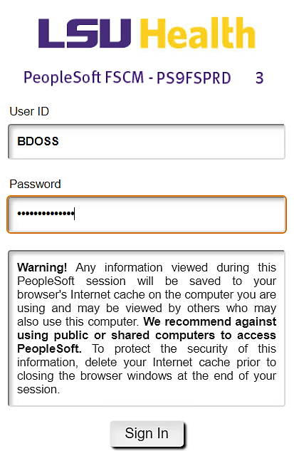

Once the Homepage opens, you may need to personalize the page to add the Approvals tile.
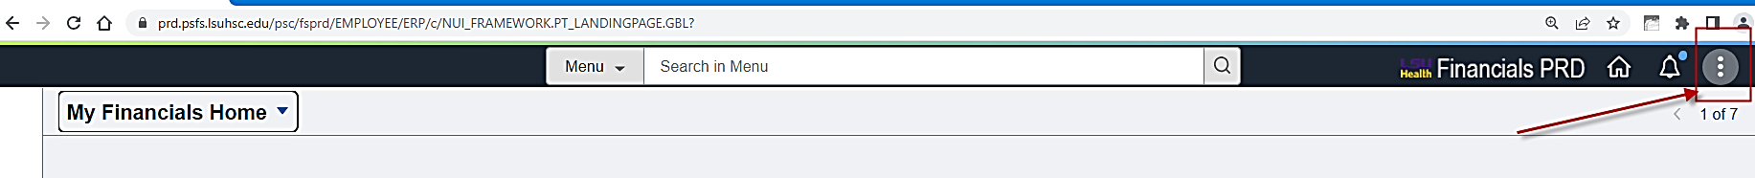
Click the eclipse (three stacked dots) 

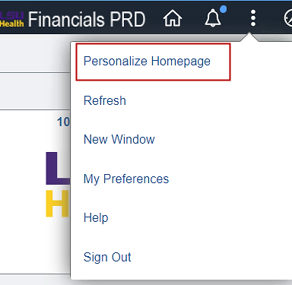
Select 

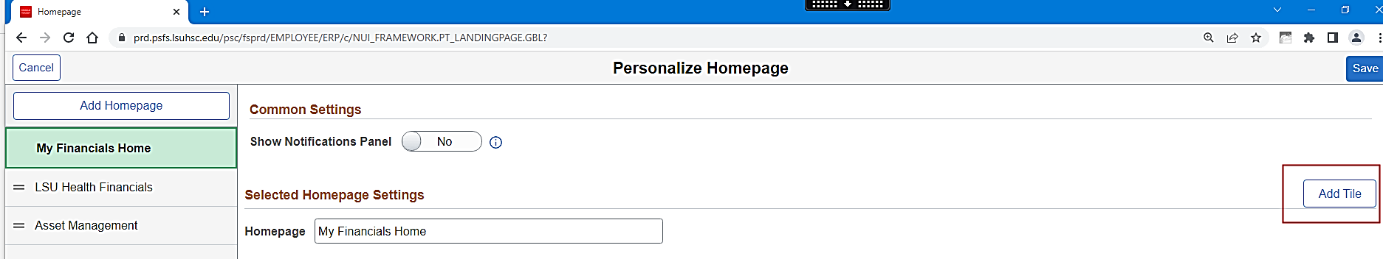
Select 

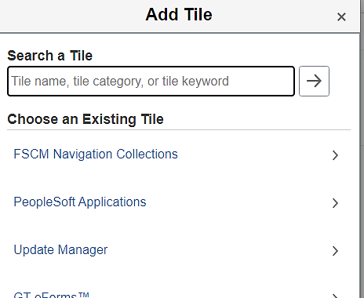
Enter the word “Approval” in the box.

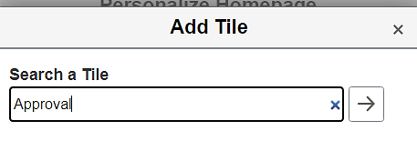
Click the 

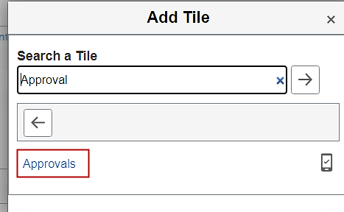
Select 

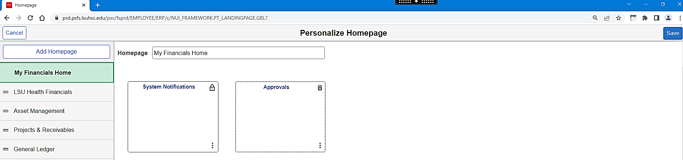
Click 

You will be returned to you Homepage. The Approvals tile is now available.
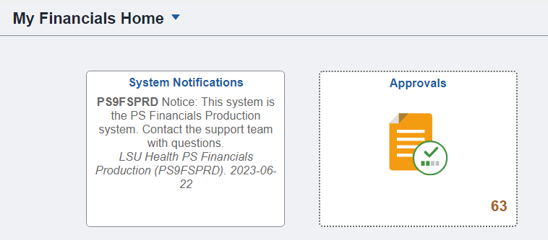

Approving Payment Requests

Approving a Payment Request via Email
Once the review step is complete, you will receive an email, similar to the one below, requesting approval.

The “sender” address will be: PeopleSoft_FS_Accounts_Payable@lsuhsc.edu.

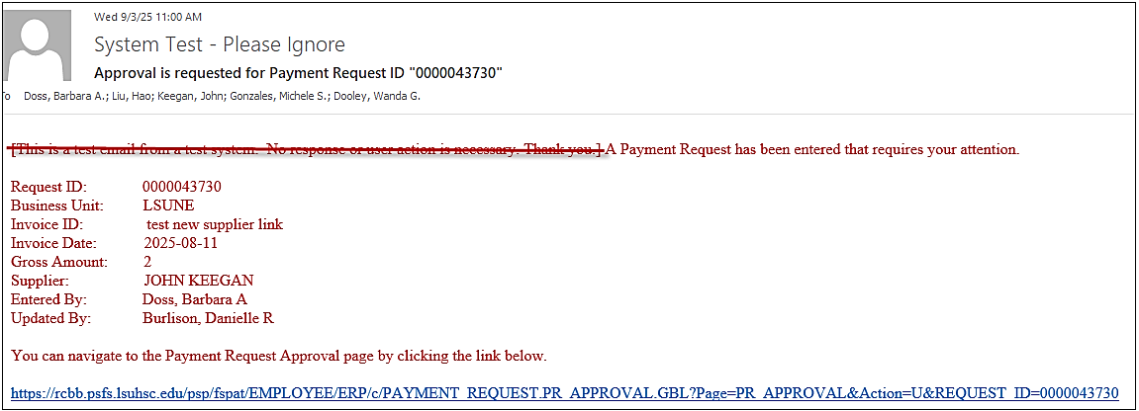
Begin your approval process by clicking the link in the email.

Log on to PeopleSoft Financials by entering your regular network User ID and Password.

The Payment Request Approval page will display.

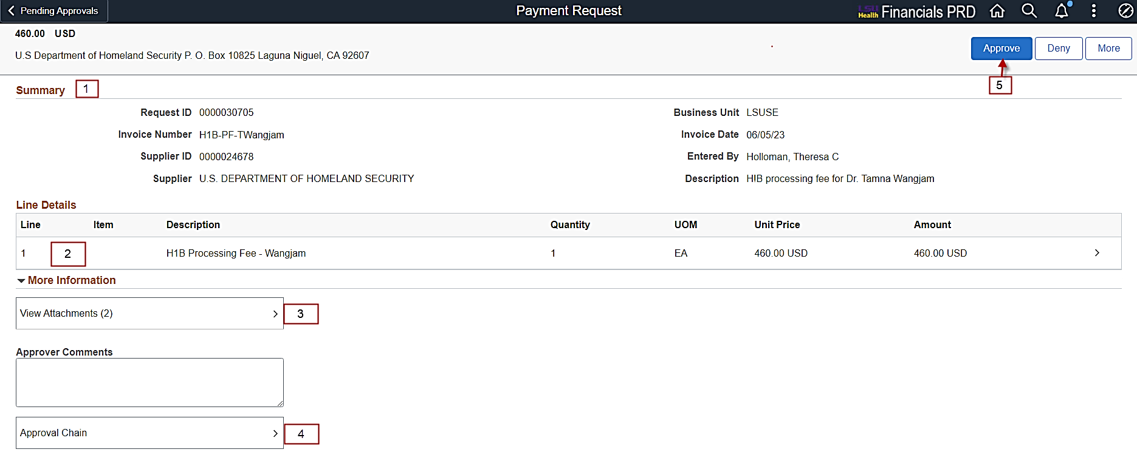

You can now do the following:

- Review Summary
Confirm that the Summary information is correct.

- Review Line Details.
Click the line to see the Chart-field distribution and confirm its accuracy.
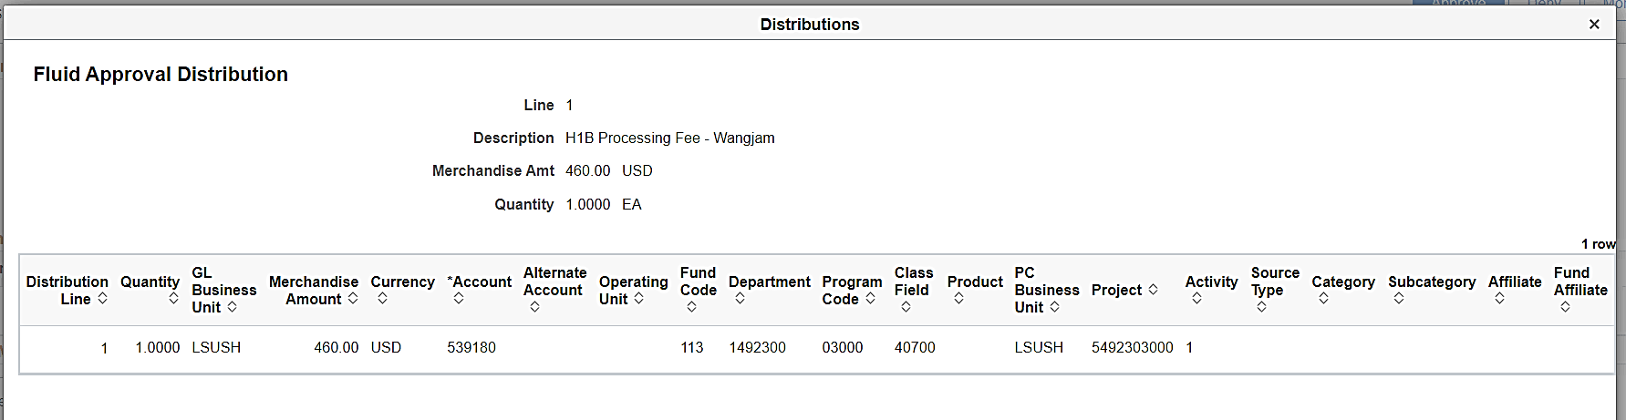
Click the  to close the Distributions page.

- Attachments
Click 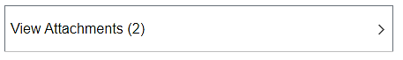

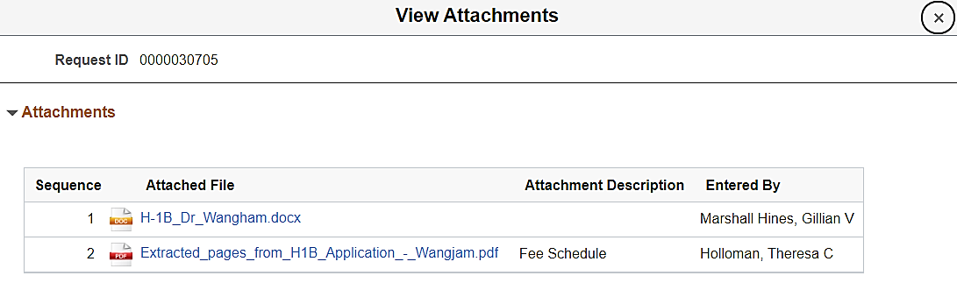
Once you are done with reviewing the attachments, click the  to close the View Attachments page.

- Approval Chain
To review who the approvers are, click the 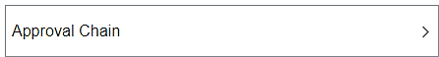 link.
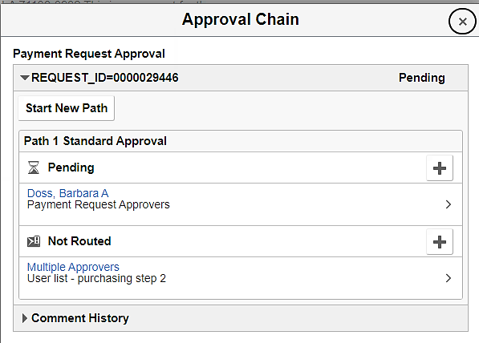
You can also click the link to view the PR’s History if desired.
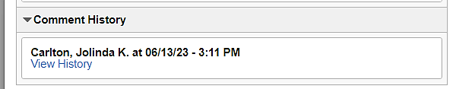

- Approve
If all information is accurate, you can approve the Payment Request by clicking the link
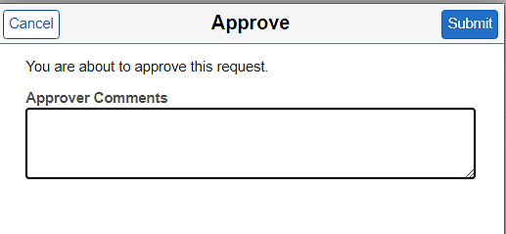
You can add comments if desired, but Comments at the time of Approval are not required.

Click

You will receive a very quick message that the Payment Request has been approved.

Note that the number of Payment Requests to approve is reduced in the menu.

Approving a Payment Request via the Approvals tile
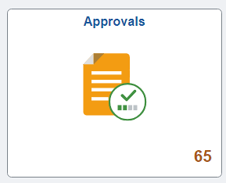
After logging into PeopleSoft, select the Approvals tile from your Homepage.

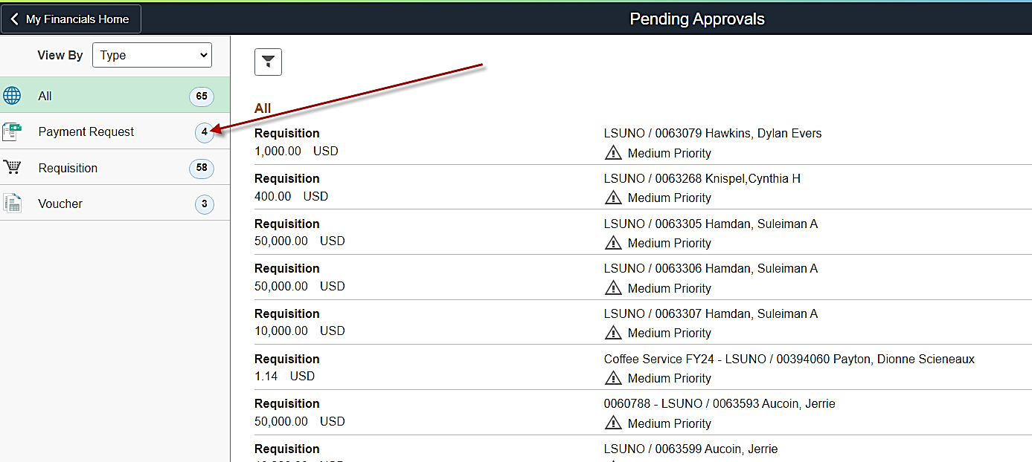
Once the Approvals tile is open, you can see everything that has your name on it to approve.

Click the "Payment Request" option in the menu.
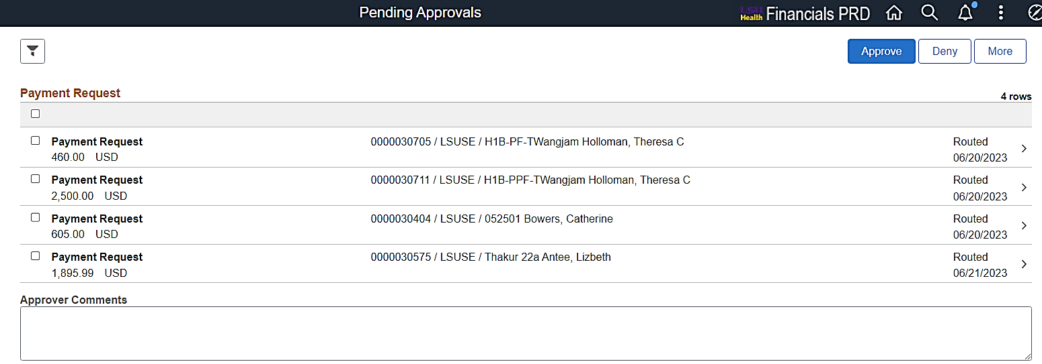
Select a Payment Request to review/approve.
You can now do the following:

- Review Summary
Confirm that the Summary information is correct.

- Review Line Details.
Click the line to see the Chart-field distribution and confirm its accuracy.
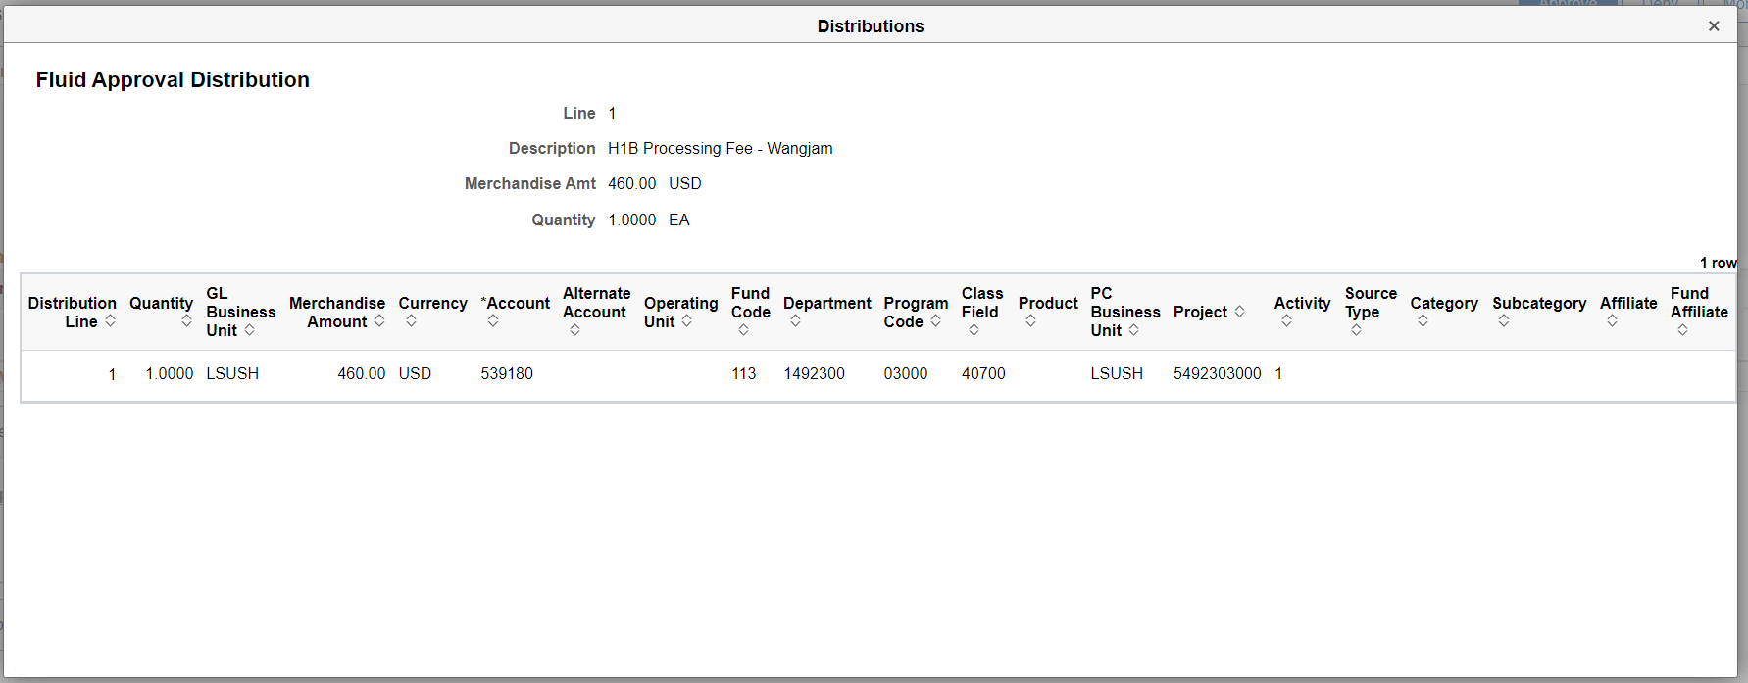
Click the to close the Distributions page.

- Attachments
Click

Once you are done with reviewing the attachments, click the to close the View Attachments page.

- Approval Chain
To review who the approvers are, click the link.
You can also click the link to view the PR’s history if desired.

- Approve
If all information is accurate, you can approve the Payment Request by clicking the link
You can add comments if desired, but Comments at the time of Approval are not required.

Click

You will receive a very quick message that the Payment Request has been approved.

Note that the number of Payment Requests to approve is reduced in the menu Payment Request list.

Placing a Payment Request on Hold
Comments are REQUIRED for Hold’s.

Click the  link.

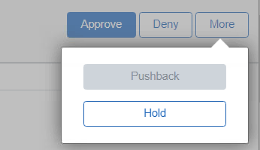
Select the  option.

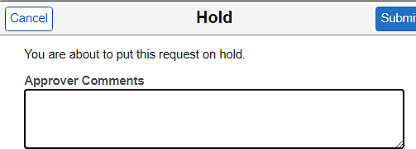
Enter your comments in the text box.

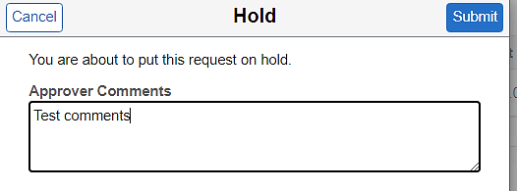
Click .

You will get a quick message: “You have put the request on hold.”

An email will be sent to the Administrators notifying them that the Payment Request has been placed on Hold.

Administrator HOLD Email sample

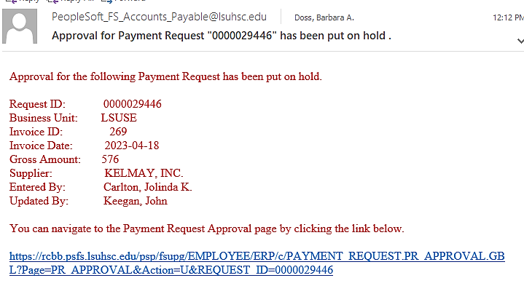

To see Comments and approvers, click the 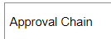 link.
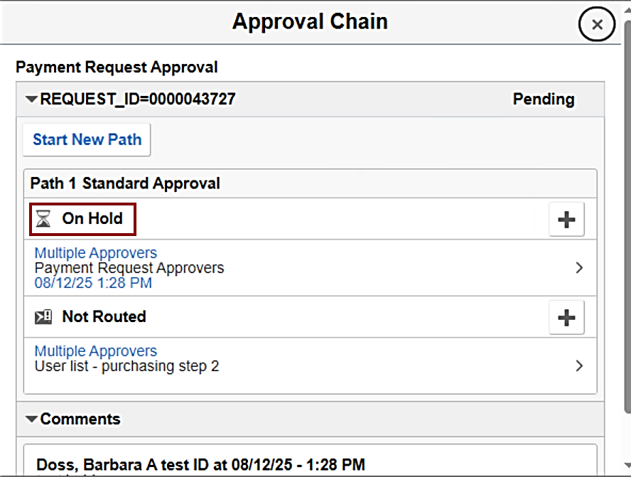

Note that the Payment Request is still available for approval and can be approved without taking the Payment Request off Hold.

When you are ready, you can click the link to approve the Payment Request.

Denying a Payment Request
Comments are REQUIRED when denying a Payment Request.

If a Payment Request needs to be denied click  link.

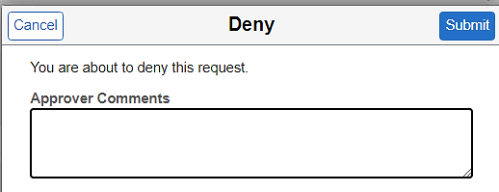
Enter comments.

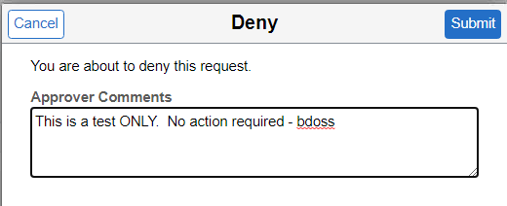
Click

You will get a quick message: “You have denied the request.”

The Payment Request will no longer appear in your list of items to approve.

An email will be sent to the Requester and ADMIN notifying them that the Payment Request has been denied.

Sample Denied email
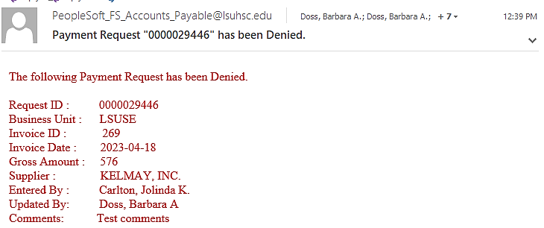

Adding Ad Hoc Approvers
Ad Hoc approvers work like a chain – you are not adding a new step with two approvers in it, you are adding two new steps with one approver each. In general, the basic approval step process is:

Department Approver > Purchasing Approver
(Business Manager)

For instances where an additional approver or approvers are needed, either the Department Approver and/or the Purchasing Approver can add an Ad Hoc Approver.

CAUTION: If for some reason, someone added 10 people in a row, the approval would go to EACH of the 10 people. EACH person will need to approve.

Department Approvers adding Ad Hoc Approvers
For this example, the Department Approver determines that an additional approver is needed. At this point the Department Approver can add one or many additional approvers.

Samples of Ad Hoc Approver scenarios

- The Department Approver adds the Department Chair as an Ad Hoc Approver. The new approval flow looks like this:
Department Approver > Department Chair > Purchasing Approver
The Department Approver does the Ad Hoc step. The Department Chair must approve the Payment Request before it goes to Purchasing. Once Purchasing approves, the Payment Request is ready for voucher processing.
- The Department Approver adds the Department Chair and the Dean as Ad Hoc Approvers.
The new approval flow looks like this:
Department Approver > Department Chair > Dean > Purchasing Approver
The Department Approver does the Ad Hoc step. The Department Chair, then the Dean must approve the Payment Request before it goes to Purchasing. Once Purchasing approves, the Payment Request is ready for voucher processing.
- The Department Approver adds the Department Chair, the Dean and the Chancellor as Ad Hoc Approvers. The new approval flow looks like this:
Department Approver > Department Chair > Dean > Chancellor > Purchasing Approver.
The Department Approver does the Ad Hoc step. The Department Chair, then the Dean, then the Chancellor must all approve the Payment Request before it goes to Purchasing. Once Purchasing approves, the Payment Request is ready for voucher processing.

To add an AD HOC Approver click the  on the Pending Approvals page for the desired Payment Request.
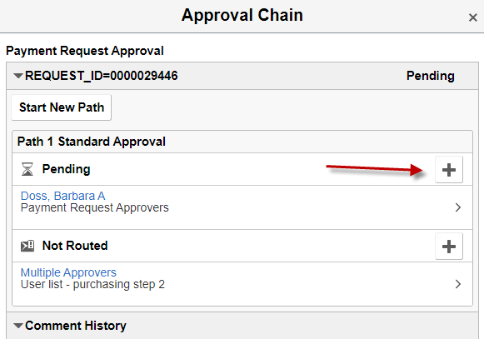
Click the sign.

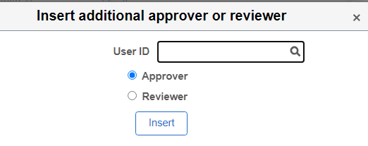
Enter the User ID (All CAPS)

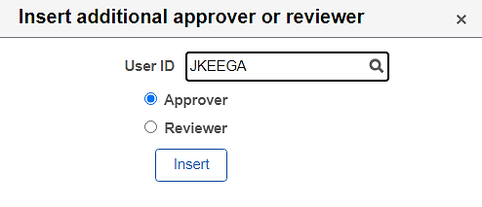
Click 

NOTE: The Ad Hoc Approver must already have approval rights/security. If you assign a Payment Request to a user who does not have the appropriate security, that user will receive an email, but will not be able to approve. When they attempt to approve the Payment Request, they will receive a message similar to the one below.

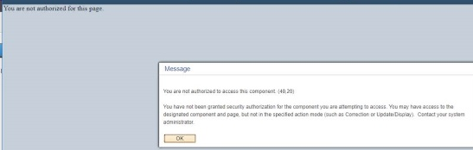
In this case ADMIN will need to assist in either obtaining the correct security for this user or re-assigning the Payment Request to a different approver.

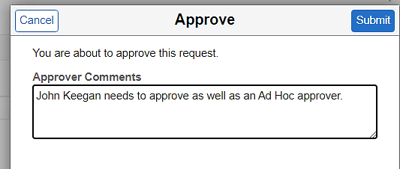
Add a comment.

Click

The Ad-Hoc User will receive the below email.

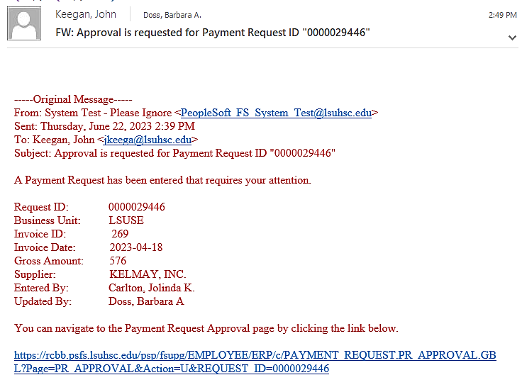
Navigating back to Payment Request Approval page will show that the Payment Request is no longer in your list of Payment Requests to approve.

Click the to close the page.

Click the link again to review the new approval routing.

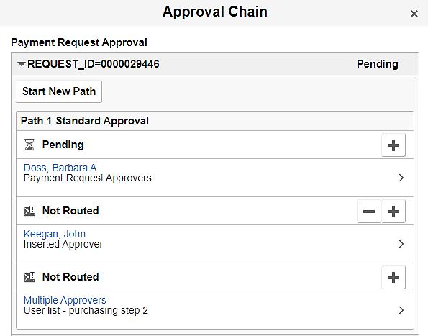
The Ad Hoc Approver is now inserted.

NOTE: This Ad-Hoc step does not approve the Payment Request; rather it approves the new workflow to route to the Ad Hoc Approver.

Purchasing Approvers adding Ad Hoc Approvers

If the Purchasing Approver adds an Ad Hoc Approver, Purchasing must first add the Ad Hoc Approver then approve the Payment Request. Since Purchasing has already approved, once the Ad Hoc Approver approves, the Payment Request is ready for voucher processing.

As the Purchasing Approver, to add the appropriate person as an Ad Hoc Approver, complete the same steps detailed above for the Department Approver adding Ad Hoc Approvers section.

Self Approvals
Payment Requests that are entered by an approver will have an approval status of “Skipped” and “Pending”. Approval for Payment Requests with this scenario will be “Skipped” as a Requester cannot self approve. If a second approver is set up for the department, they must approve. If no other approver exist for the department, the Payment Request will be routed to ADMIN. ADMIN will get the correct approver set up and re-submit the request for approval.

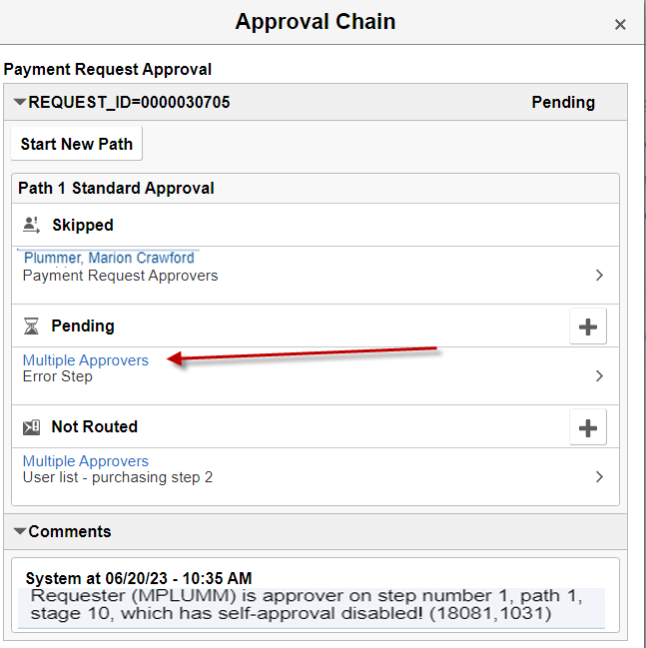

Missing Department Approvers – (ADMIN Approvers only)
There may be instances where a department is missing an approver. These Payment Requests are identified with an approval status of at Path 1 – Standard Approve - Skipped.

This indicates that when workflow was initiated, there was no Department Approver found for that department.

In this instance workflow pushes the Payment Request to the next approval level which is the ADMIN group, thus the Payment Request must be addressed by the ADMIN.

ADMIN Action: Admin will need to identify the correct user as the Department Approver, gain approval to add the new approver to PeopleSoft (if applicable) and add the correct role to the users’ security profile. Once the Department Approver is added, ADMIN will “RESUBMIT” the Payment Request into workflow. The new approver will approve.

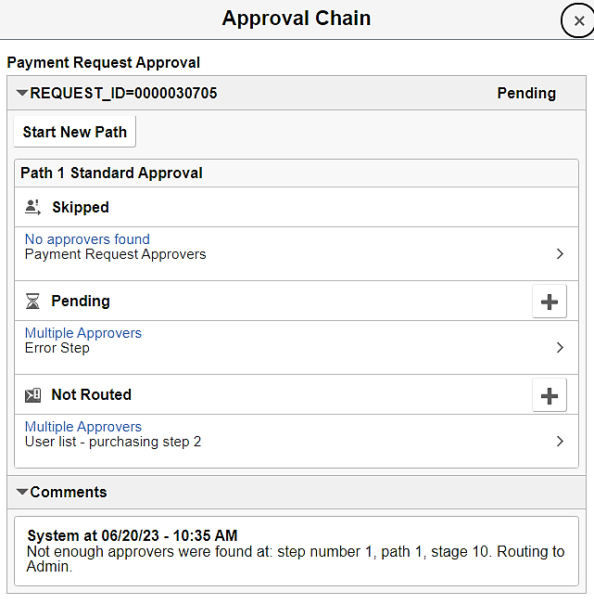

Pushback
There may be some instances where the Payment Request is not necessarily wrong, but requires additional information before it can be approved.

For this situation, the Pushback functionality can be used. This functionality is only available for Ad Hoc Approvers and Purchasing Approvers.

NOTE: AFTER clicking the Pushback link be sure to add a comment detailing why the transaction is being pushed back.

Whether you are the Ad-Hoc approver OR the Purchasing Approver, the process is the same.

Click the link.

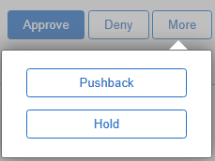
Select the  option.

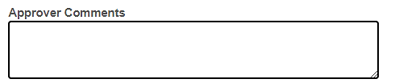
Enter necessary comments.

Click

The previous “Approved” status reverts to “Pending.” If the previous approver is an Ad Hoc Approver, he or she can either Deny with comments, Approve again or do a Pushback to the Department Approver with comments.

The Department Approver, will receive the email below.

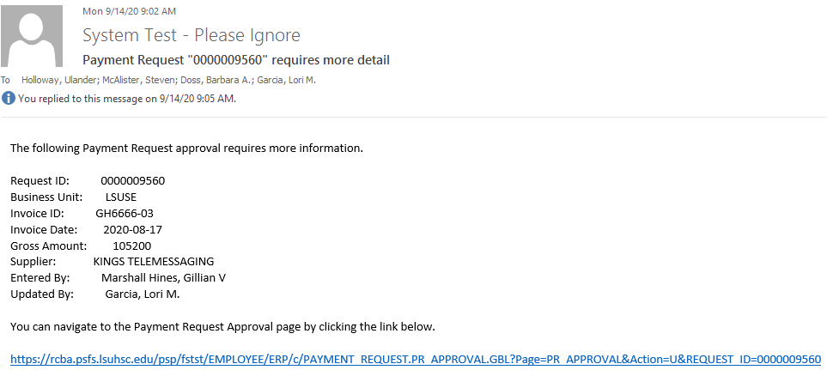

Approval Timeouts

Notification Escalation Process
Notifications are dependent on NEM_VAF_ESCALATION job that runs each day at 5:10 am. This job detects when a record has become ‘overdue’, it will notify the Requesters at that time.

Timeout Schedule
The TIMEOUT notifications are set for ALL paths at 7, 14, 21 and 28 days intervals.

Payment Requests that are not approved, denied, or placed on hold will be subject to email reminders on a 7, 14, and 21-day schedule.

An email reminder, similar to the one shown below, will be sent to the assigned approver(s) based on the above timeline.

On the 28th day, an email is sent to the PR Administrators.

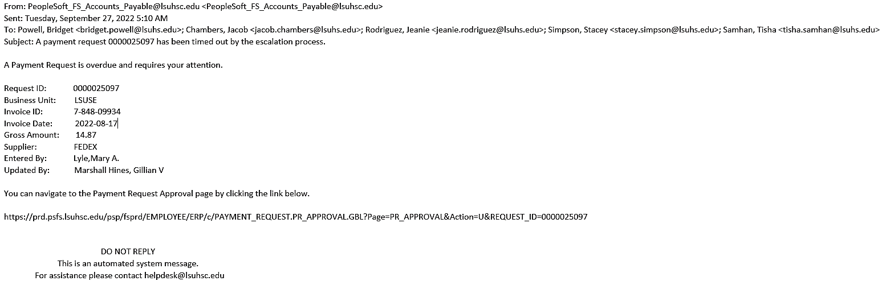

Payment Request Queries

PR_BY_DEPARTMENT – Payment Requests by Department
- List all Payment Requests for a given Department by date range regardless of status.
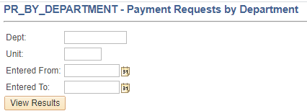
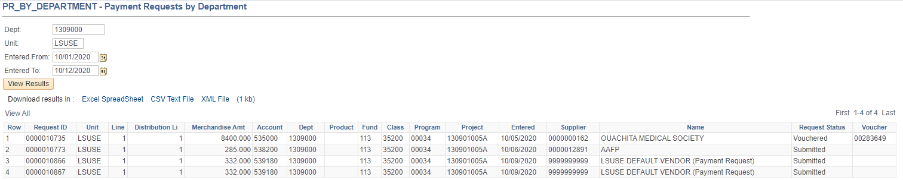

PR_BY_DEPARTMENT_PENDING - Payment Requests by Dept-Pending
- List all Payment Requests with a status of Pending for a given Department by date range.
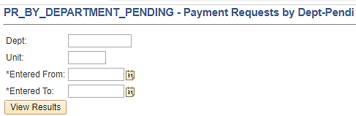
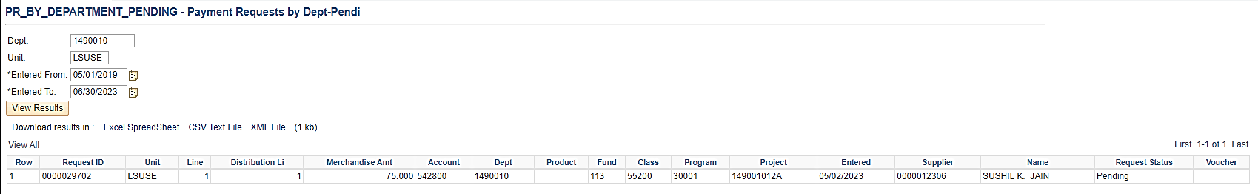

FAQ – Frequently Asked Questions

Scanning
- What if scanner doesn’t have the correct driver?
  - Contact your local campus IT Support department.

- When more than one document needs to be attached, can they be scanned as one document?
  - No.
    - W-9s must be scanned and attached separately. All other documents may be combined into a single file.

- Does the Payment Request have a template you can save?
  - No.

- Are attachments required?
  - Yes.

Creating Payment Requests
- Who can create the Payment Request?
  - Anyone with the correct security role and route control.

- What if the PR Requester doesn’t know which account code to use?
  - See the Policy – Types of Purchases Not Allowed section found at the beginning of this document.
  - If you require additional assistance, contact Travel & Direct Pay at shvmstraveldirectpay@lsuhs.edu.

- Can I create a credit Payment Request?
  - No. The system is working as designed. Payment Requests are not designed to work like a Regular Invoice. Currently only payments with positive amounts can be created from the Payment Request Review Center. Credits can be entered as regular vouchers.

Reviewing Payment Requests
- If DP needs more documentation in order to pay a Payment Request, how is the department notified?
  - DP will create a Payment Message within the Payment Request record which will trigger an email to the PR Requester.

Approving Payment Requests
- Why is workflow setup like that? Shouldn’t DP be at the end?
  - Workflow is set up to flow from PR Requester > Direct Pay PR Reviewer > Department Approver > Purchasing Approver.
Since Payment Requests produce a fiduciary responsibility, the DP staff are not allowed to act on behalf of another person to approve payments of any kind. That responsibility falls to the Department Approvers and Purchasing Approvers.

- Can the PR Requester approve his/her own Payment Request?
  - No.

- Can the PR Requester also be an approver?
  - Yes, but not for Payment Requests they create.

- If a Coordinator creates the Payment Request, is there a way for the Business Manager to electronically sign it showing they approve the Payment Request?
  - Yes, via Payment Request workflow; if the Business Manager has been assigned Approval authorization for that department.

- Will the Payment Request be sent to Purchasing for their approval before it goes to Direct Pay?
  - No. The Payment Request must first go to the Direct Pay PR Reviewer for review, then to the Department Approver for approval. Once approved by the Department Approver, Purchasing will do a final approval.

- What happens if a Payment Request is denied?
  - Payment Requests can only be denied by either the Department Approver or the Purchasing Approver. If an Approver denies the request, an email will be sent to the PR Requester and the PR Administrators for follow-up.

- When a PR Requester clicks on the look-up icon for approvers, who will show in the drop-down approver list?
  - All authorized approvers for the Department ID will appear in the drop-down list and Purchasing Approvers.
  - If the individual submitting a Payment Request (PR Requester) also has authorization to approve Payment Requests, they will only see Payment Request’s drop-down list as an Approver. This upholds institutional policy for “separation of duties”, where Payment Request Requesters are not permitted to approve Payment Requests they create.

- What if the approvers are incorrect?
  - To add/delete or change approvers for a department, the Department Head must send, via email, authorization to Travel & Direct Pay at shvmstraveldirectpay@lsuhs.edu.

Payment Request Vouchers
- Once the PR Reviewer reviews a Payment Request, will a voucher number be created and sit there until the next check run?
  - No. Once the Payment Request is reviewed, workflow is triggered and the Payment Request is sent to the Department Approver. Once the Department Approver approves the Payment Request, workflow is triggered again and the Payment Request is sent to the Purchasing Approver. Once Purchasing approves the Payment Request, it becomes available for the Voucher Build process, which is scheduled to run daily, to create the actual voucher. At this point the voucher is available for the payment processing steps.

- A Payment Request shows vouchered in the PR Center; however, it is not viewable in the AP lookup screens and has not been paid.
  - When the Voucher Build process was run there was an error with either Supplier ID, location, etc. The error was never corrected via Voucher Build Error Detail page. The PR Reviewer must correct the problem. The voucher will then show correctly in the Payment Request Center.

Payment Request Payment Confirmation
- What will be sent back to the department as supporting documentation?
  - A copy of the Payment Request Detail page summarizing the Payment Request information will be attached to the check.

END OF PROCESS

